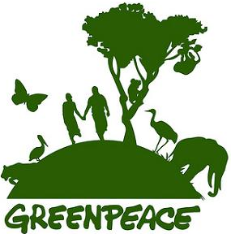
What Is Greenpeace?
Greenpeace exists because this fragile earth deserves a voice. It needs solutions. It needs change. It needs action.

Greenpeace is an independent global campaigning organization that acts to change attitudes and behaviour, to protect and conserve the environment and to promote peace by:
- Creating an energy revolution to address the number one threat facing our planet: climate change.
- Protecting the world's ancient forests and the animals, plants and people that depend on them.
- Defending our oceans by challenging wasteful and destructive fishing, and creating a global network of marine reserves.
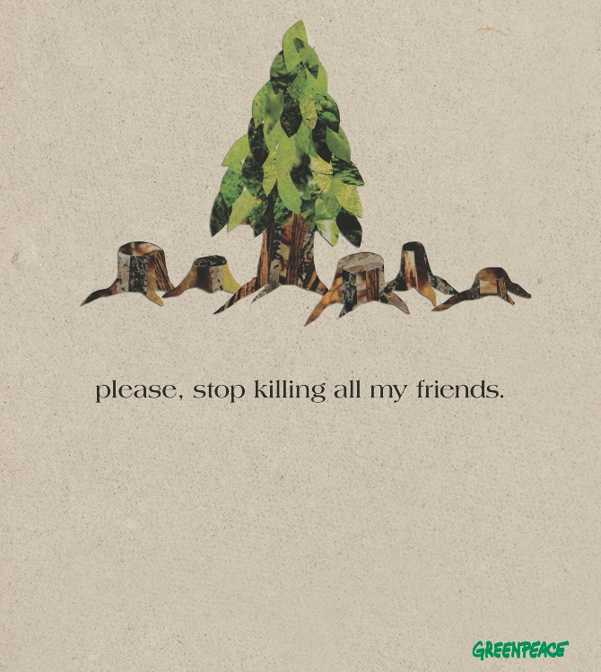
- Campaigning for sustainable agriculture by rejecting genetically engineered organisms, protecting biodiversity and encouraging socially responsible farming.
- Creating a toxic free future with safer alternatives to hazardous chemicals in today's products and manufacturing.
"When the last tree is cut, the last river poisoned, and the last fish dead, we will discover that we can't eat money..."

