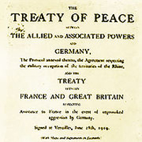
The End of the War and the
Treaty of Versailles
At 11 o'clock in the morning of the 11th day of the 11th month of 1918, the First World War, known at the time as the Great War, comes to an end. We know this day as ______________________________________

In the fall of 1918, the power held by the Triple Alliance was unraveling in its war effort.
Issues:
- better ____________________ and ____________________ Allied powers
- facing ____________________________________________ on the battlefield
- __________________________ on the home front
- _______________________of Germany’s weaker allies, Austria-Hungary, Bulgaria and the Ottoman Empire, forced the country to seek an _______________________ ( )with the Triple Entente in the early days of November 1918.
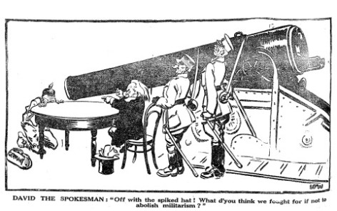

The Details:

The Treaty of Versailles was made by the_____________________________________ after WWI (in June 1919). This group was known as the_____________________________________________. Their goal was to _______________ the start of another __________________________. Most ___________________ thought the Treaty was___________. This led to __________________ and ___________________________.

Conditions of the Treaty:

Geography
- Germany lost all of their ___________________________
- They lost land to ___________________ in the _______________
- They also lost much of Eastern Europe, which created _____________________
- France also took _________________of many of their _____________________ ( )

Military
- The German _________________ was restricted to _______________________ people
- No ___________________ or heavy __________________
- No ___________________________
- The navy could only have ___________________ ships (no ____________!!)

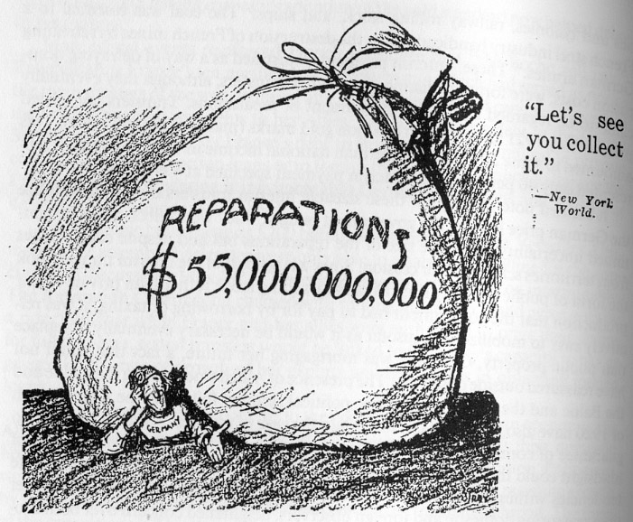
Reparations

- This means to ___________________ to ____________________ the __________________________ of war
- They had to pay ___________________, ____________________ and __________________ money and goods
- This was estimated at about __________________________________ (about 440 billion dollars today)
DEBATE QUESTION:
Do you think the Treaty of Versailles was too harsh on Germany? (or do you think they got what they deserved?) You need to provide as many points for one side as you can fit in the space below. Do NOT conference with your classmates!

