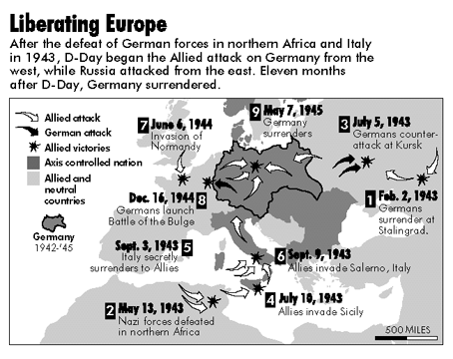
The End of the War - The Liberation of Europe, VE & VJ Day
Liberation of Europe
From D-Day to April 1945 pushed the Germans back to Berlin
The final defence of Berlin included young boys and the elderly – The German army was defeated

The End of the Dictators
In Italy Mussolini is captured and hanged by his own people (April 1945)

Hitler’s Death
Hitler commits suicide and orders his body burned afterwards – April 30, 1945
Nazi propaganda says he died a hero’s death leading his troops in battle.
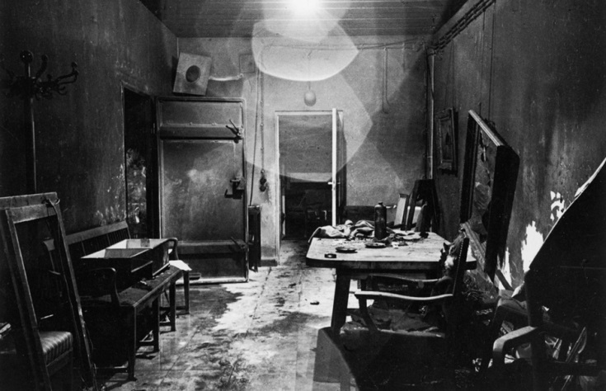

Victory Europe Day
One of Hitler’s final orders is to fight to the death
Germany formally surrenders May 8, 1945
Although very important, war still continues in Japan

Dropping the Bomb and Victory Japan Day
Background – The Manhattan Project
TMP was the U.S. government research project (1942–45) that produced the first atomic bombs.
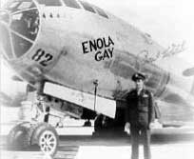
Canada supplied and refined uranium for use in U.S. facilities.

C.D. Howe was Canada's wartime cabinet minister who formally entered Canada into the nuclear age.
On August 6th 1945 the Americans dropped the world’s first atomic bomb on Hiroshima
- August 9th they dropped another bomb on Nagasaki
- The Japanese surrender on August 10th.
- The pilot was Paul Tibbets
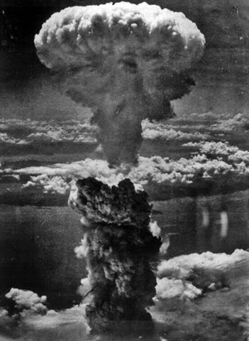
- The plane that dropped the bomb was the Enola Gay
- It was named after the pilot’s mother
- Fat Man was dropped on Nagasaki
- Little Boy was dropped on Hiroshima

Casualties
It estimated that at Hiroshima 70,000+ died instantly – Over 250,000 died later from results of the explosion or radiation sickness.
At Nagasaki over 50,000 were killed instantly with many more after as well

