Unit #1: Canadian Government & Law
Leadership and Canadian Democracy
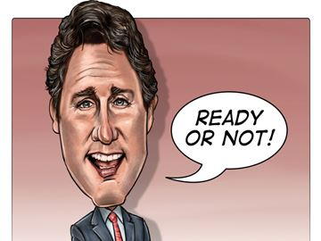

Monday | Tuesday | Wednesday | Thursday | Friday
6  Intro to Civics and course outline + writing/opinion task | 7  Intro to leadership and civic duty – My civic role. | 8  Continued… | 9  How does leadership evolve?  Trolls and Zombies… | 10  Zombies continued…
13  Newspaper fashion show | 14  Leadership styles | 15  Quiz | 16  Canadian Democracy and the Political Spectrum | 17  Canadian Federal Political Parties
20  Political Parties work period – Lab | 21  Political Parties presentations | 22  Canadian Charter of Rights and Freedoms map | 23  Canadian Charter of Rights and Freedoms | 24  IPads Levels and Branches
27  Levels and Branches | 28  Test Review | 1  Unit Test
