The Road to World War 2
Germany Rearms, 1933
- Hitler becomes Chancellor of Germany
- Immediately begins rebuilding the military
- Military slogan: “Today Germany, tomorrow the world!”

Mussolini Invades Ethiopia, 1935
- Italy invades Ethiopia for its oil
- The League of Nations takes no decisive action

Hitler Occupies the Rhineland, 1936
- German troops take the Rhineland, also against the Treaty of Versailles
- League of Nations does nothing

Hitler Occupies the Rhineland, 1936
- German troops take the Rhineland, also against the Treaty of Versailles
- League of Nations does nothing

Germany Annexes Austria (Anschluss with Austria), 1938
- Nazi soldiers occupy Austria without a single shot being fired
- League of Nations does nothing – Are trying to avoid another war by taking no action

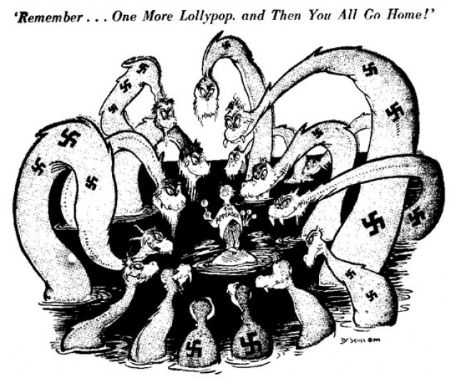
The Policy of Appeasement, Sept. 1938
- Hitler meets with world leaders and signs the Munich Agreement
- They allow Hitler to take the Sudetenland (part of Czechoslovakia) because they believe it will stop another World War.

Rome-Berlin Axis Pact, Oct. 1938
- Mussolini spreads fascism in the south, Hitler does so in the north
- Japan joins this alliance in 1940

Full Occupation of Czechoslovakia, March 1939
- A direct act against the Munich Agreement

Non-Aggression Pact with Soviet Union, August 1939
- This agreement says Germany and Soviet Union will not invade or fight in the event of war
- They also secretly agree to divide Poland
- Hitler no longer fears attack in the east and can concentrate on France and Britain

Invasion of Poland, Sept. 1 1939
- Hitler demands the Polish Corridor be given back to Germany
- Poland refuses
- Nazis respond with Blitzkrieg (lightning war) and takes Poland quickly

Britain and France Declare War, Sept. 3 1939
- Both nations realize the failure of appeasement
- World War 2 has begun!
- Canada joins on Sept 10

