The Holocaust

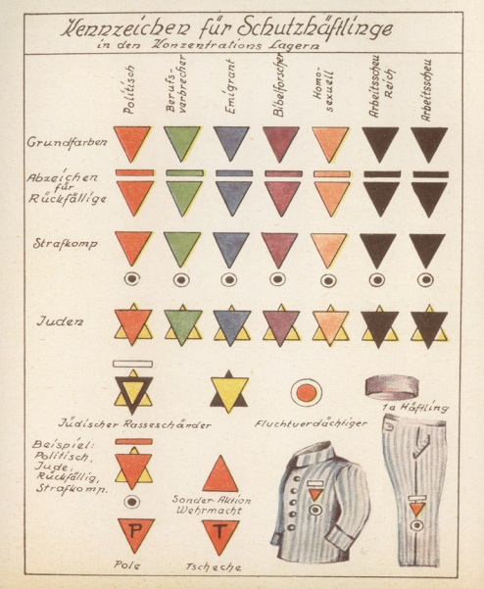
Classification and Segregation
- This is the rise of “anti-Semitism” – the hatred of the Jewish people
- It creates an “us vs. them” feeling in Germany by using the Jews as scapegoats
- This also allows for intense nationalism

The Nuremberg Laws
The Nuremberg Laws (1935) were designed to establish a defined German state and promote hate towards Jewish citizens in Germany.
Some notable features included:
- Marriage and relationships between Germans and Jews was prohibited (The Law for the Protection of German Blood and Honour)
- German-born Jews were stripped of their citizenship (The Reich Citizenship Law)

Identification in the Camps
- Yellow Star (of David) – __________________
- Red Triangle - ______________________________
- Green Triangle – ___________________________ – “The Kapos”
- Purple Triangle – ____________________________ including ________________________, Bible Students etc.
- Black Triangle – deemed “asocial” including the ____________________________________________________ ___________________________________________________________________________________________
- Pink Triangle – ___________________________
- Brown Triangle – Roma Peoples (________________)
- Blue Triangle – Immigrant Forced Labourers

Dehumanization – Rules and Laws
- Boycott of Jewish _______________________
- Removal of Jewish ___________________ from the calendar
- Jews had to carry _____________________________
- They were banned from attending cultural events
- A _________________ was put in place

Kristallnacht
- “The Night of the ______________________” – This marked the next level of the Holocaust
- It started when a Polish student shot a German diplomat (Nov. 7 1938)
- Hitler immediately organized a program – organized killing – for Germany and Austria
- Over 7500 Jewish businesses were _________________________________
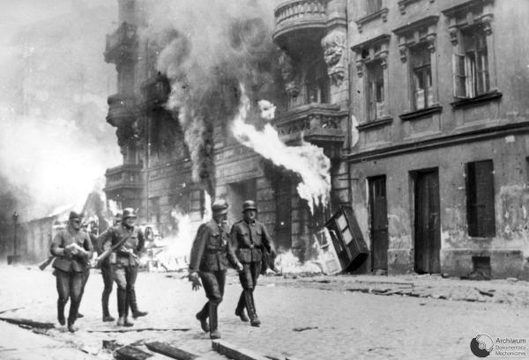
- Over 170 _____________________ were burned
- Between 20,000 – 30,000 Jews were arrested and sent to concentration camps

Organization and Polarization – The Ghettoes
- A walled area within a city to _______________ the Jewish population
- Conditions horrible; food is limited
- Ghettoes also provided a source of _________________________
- Warsaw Ghetto is approx 1016 acres for 500,000 people

The Warsaw Ghetto Uprising
- April 19 – May 19, 1943
- Hitler announced all surviving Jews in the ghettoes would be taken to the camps

The Warsaw Ghetto Uprising cont…
- When the Germans began to deport those left the resistance began
- 750 resistors with handguns and 17 rifles faced more than 2000 Nazis
- The Nazi general ordered the ghetto burned
- The Jews held out for an amazing 27 days
- 300 Germans were killed
- 7000 Jewish fighters were also killed
- Everyone else was captured and taken to the camps

Preparation - The Camps
- Originally, camps were occupied by prisoners to work for the German war effort
- The ______________ camp was _______________ (1933) outside of ___________________
- Upon arrival at the camps prisoners were subjected to “_____________________”
- There were two types of camps: ___________________and__________________

Auschwitz
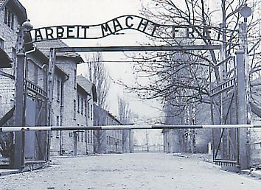
“The Fuhrer has ordered that the Jewish question be solved for once and for all, and we, the SS, are to implement that order.” (Rudolf Hoess)
- The largest and most infamous _______________________ camp. Auschwitz used both ____________________ and _______________________
- Estimates of the number killed at Auschwitz vary between _____________________________
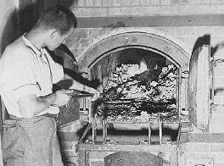
- As with most camps, Auschwitz had the ominous gate saying “Arbeit Macht Frei” – _______________________

Extermination – _______________________
- This was the systematic “___________________” of the ghettoes to death camps
- It also included mobile killing units
- In the final days of the war Jews were executed or marched from the camps to “__________________________”

Joseph Mengele
- Known as the “_______________________”, he was responsible for selection at Auschwitz
- “_____________________________” included pressure chambers, freezing people to death, intentionally infecting disease, experimentation on pregnant women, twins, and more.

Denial – The End of the War
- The first deniers were the Nazis – they tried to hide their actions in any way possible
- Denial continues through neo-Nazi groups, the KKK, and others
"The opposite of love is not hate, it's indifference. The opposite of art is not ugliness, it's indifference. The opposite of faith is not heresy, it's indifference. And the opposite of life is not death, it's indifference." (Elie Wiesel)

The War Crimes Trials
- Starting with the Nuremberg Trials, Nazi officials were tried for most of the 1940’s
- Many Nazis fled Europe in hopes of escaping trial
- That said, 1000’s of Nazi war criminals were executed, jailed or committed suicide after the war

