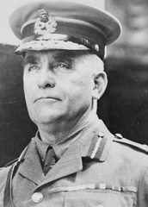
Sir Sam Hughes
Sir Sam Hughes, Canada's Minister of Militia and Defence from October 1911 to November 1916, was the driving force behind Canada's early war effort.
Hughes was a poor organizer prone to patronage and cronyism in awarding military promotions and munitions contracts. Many of his favourite equipment projects were embarrassing failures. Hughes had championed the purchase of the Canadian-made Ross rifle, carried by Canadian troops at the outbreak of war.

The Ross Rifle
In trench conditions, surrounded by mud and filth, and when it was essential to have a reliable weapon, the Ross failed. It had a long barrel and was difficult to use in the trench's tight spaces, and it frequently jammed.

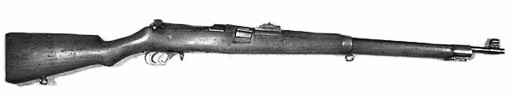

At Ypres, the Canadian First Division threw away their Ross rifles in despair and frustration, and picked up Lee-Enfields from dead British soldiers on the battlefield.
In spite of this, the Second Division went to France with Ross rifles and again the results were much the same, with solders throwing away jammed weapons. To the end, Hughes refused to accept that there were problems with the Ross, even when Sir Douglas Haig had them replaced in 1916.

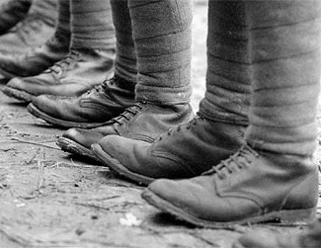
Hughes was also nicknamed “Sir Sham Shoes” because he was known to be cheap, and he made the troops wear boots with soles made of cardboard. He also instructed men to paint horses black, because they were harder to see at night and they did not want to pay for actual black horses. He was dismissed from the war.

Sir Sam Hughes
has been removed from Cabinet and from his duties and responsibilities. He has embarrassed Canadians. Do you think he should
be Court Martialed!

In the space below, create a case against him. Remember to mention how he let down our boys and his actions cost thousands of Canadian lives.

OR…

Create a case for him/on his behalf proving that his actions were justified when dealing with the resources, limited time to make decisions and financial support he had at his disposal.

