Significance of the Title Of Mice and Men

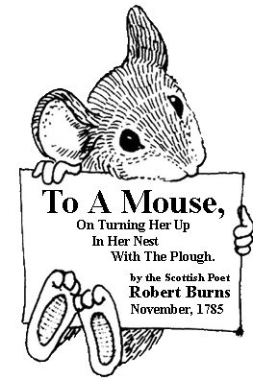
The title Of Mice and Men is in reference to Robert Burns' poem To a Mouse, On Turning Her Up In Her Nest With the Plough.

Consider the phrase "the best laid plans of mice and men often go awry."

How does this apply to the novella?

The significance of the title is in the futility of planning and the inevitability of failure if the odds are stacked against you, as they are for George and Lennie.

The novel is a condemnation of the American Dream, and how it is just out of reach. It also addresses the American Constitution. All men are not created equal in the eyes of humanity, and characters like Lennie and George will always be judged by their weaknesses rather than their strengths.

To A Mouse by Robert Burns
On Turning Her Up in Her Nest with the Plow
November 1785

Small, sleek, cowering, timorous beast,
O, what a panic is in your breast!
You need not start away so hasty
With hurrying scamper!
I would be loath to run and chase you,
With murdering plough-staff.
I'm truly sorry man's dominion
Has broken Nature's social union,
And justifies that ill opinion
Which makes thee startle
At me, thy poor, earth born companion
And fellow mortal!
I doubt not, sometimes, but you may steal;
What then? Poor beast, you must live!
An odd ear in twenty-four sheaves
Is a small request;
I will get a blessing with what is left,
And never miss it.
Your small house, too, in ruin!
It's feeble walls the winds are scattering!
And nothing now, to build a new one,
Of coarse grass green!
And bleak December's winds coming,
Both bitter and keen!
You saw the fields laid bare and wasted,
And weary winter coming fast,
And cozy here, beneath the blast,
You thought to dwell,
Till crash! the cruel plough past
Out through your cell.
That small bit heap of leaves and stubble,
Has cost you many a weary nibble!
Now you are turned out, for all your trouble,
Without house or holding,
To endure the winter's sleety dribble,
And hoar-frost cold.
But Mouse, you are not alone,
In proving foresight may be vain:
The best laid schemes of mice and men
Go often askew,
And leaves us nothing but grief and pain,
For promised joy!
Still you are blest, compared with me!
The present only touches you:
But oh! I backward cast my eye,
On prospects dreary!
And forward, though I cannot see,
I guess and fear!

