CHC 2D – WWI: Causes & Early War
The Main Players
Triple Entente Leaders |  |  |  | Triple Alliance – Central Powers
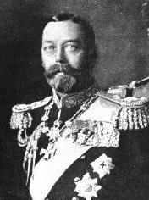  King George V - Britain | 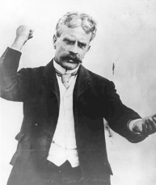  Robert Borden – Prime Minister of Canada | 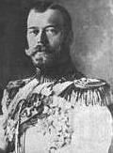  Czar Nicholas II - Russia | 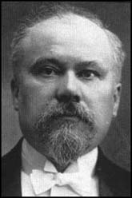  President Poincare - France | 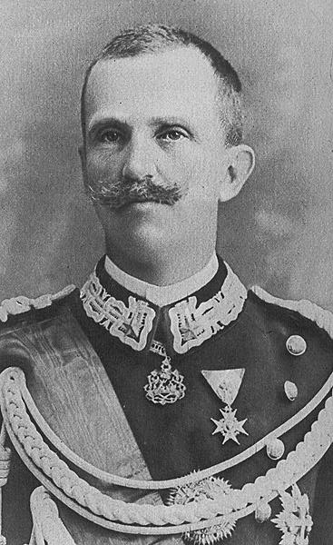 Victor Emmanuel - Italy | 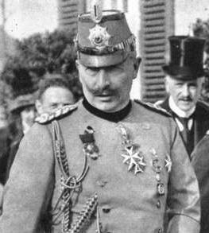 Kaiser Wilhelm II | 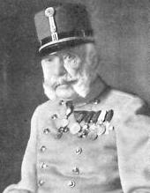  Franz Joseph – Austria-Hungary

The Schlieffen Plan

"Paris for lunch, St. Petersburg for dinner."

Years before the start of World War 1, Alfred Graf Von Schlieffen devised a plan for the invasion of France through Belgium. This became known as the "Schlieffen plan".

- On August 2nd 1914 the Schlieffen Plan was put into action when Germany invaded Luxemburg and Belgium.

- The Germans soon realized that the Belgian army wouldn't be as easy as they first thought and the Belgians held their ground.

- The Germans were shocked at how quickly the British Expeditionary Force reached France and Belgium. They were also surprised by the Russian advance on East Prussia.

The French 5th army and the British advanced into the gap, splitting the 2 German armies.
In the next 3 days German forces were unable to break through the allied lines.
The French 6th army came very close to being defeated but were saved by 6000 reserves who were rushed to the front line in taxi cabs from Paris.
On the 9th of September Von Moltke ordered Von Bulow and Von Kluck to retreat.
The British and French forces could now cross the Marne, and the Schlieffen plan had failed.
The German army had not been beaten though and had a successful retreat and the trenches they built between the Swiss border and the North sea killed any hopes of a short war.

The Schlieffen Plan failed. Germany has not been defeated – they just retreated.
This created a divide between Germany (Triple Alliance) and France (Triple Entente)

As a result, Germany and France dug in and began to dig trenches. Both France and Germany thought they could outflank the other and thus began the Race to the Sea. A stalemate ensued where neither side advanced. This was the beginning of the realization that this was NOT going to be a short war.

