The Rise of Adolf Hitler and the National Socialist Regime

Adolf Hitler – Youth and Early Life
Describe Hitler’s childhood and early life.

Early Beliefs as Expressed in Mien Kampf
Examine the two translated passages and explain how Hitler exemplified his desires/plan for Germany.

Hitler’s 25 Points and the Basis for the National Socialist German Workers Party (NSDAP or Nazi = Nationalsozialismus
After examining the 25 points, why do you think this plan would have appealed to the German people enough to give Hitler merit?

Hitler’s use of propaganda
How did Hitler use propaganda to his advantage?

Hitler and the German Economy
How did Hitler bring Germany out of the Depression?

What happened to individuals unwilling to work?

What rewards and luxuries did he provide?

Putting Ideologies into Action
Examine the Nuremberg Law. Summarize key points.

1. Adolf Hitler – Youth and Early Life
Adolf Hitler was born on 20 April 1889 in the small Austrian town of Braunau to Alois Hitler who later became a senior customs official and his wife Klara, who was from a poor peasant family.
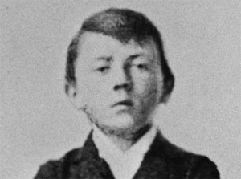
At primary school, Hitler showed great intellectual potential and was extremely popular with fellow pupils as well as being admired for his leadership qualities. However, competition at secondary school was tougher and Hitler stopped trying as a result.
He also lost his popularity among his fellow students and instead preferred to re-enact battles from the Boer war with younger children. At the age of 15, he failed his exams and was told to repeat the year but he left without a formal education instead.
At the age of 18, he moved to Vienna with money inherited after his father's death in 1903, in order to pursue a career in art, as this was his best subject at school. However his applications for both the Vienna Academy of Art and the School of Architecture were rejected.
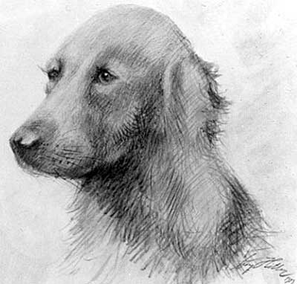
It was supposedly at this time that Hitler first became interested in politics and how the masses could be made to respond to certain themes. He was particularly impressed with the anti-Semitic, nationalist Christian-Socialist party.
During the First World War he volunteered to fight for the German Army and gained the rank of corporal, earning accolades as a dispatch-runner. He won several awards for bravery, including the Iron Cross First Class.
In October 1918, he was blinded in a mustard gas attack. Germany surrendered while Hitler was in hospital and he went into a state of great depression, spending lots of time in tears. After the war ended, Hitler's future seemed uncertain.
In 1919, Hitler attended his first meeting of the German Workers' party, an anti-Semitic, nationalist group as a spy for the German Army. However, he found he agreed with Anton Drexler's German nationalism and anti-Semitism. He disagreed with how they were organised leading him to make a passionate speech. Hitler quickly cemented his reputation as an engaging orator through his passion about the injustices faced by Germany as a result of the Treaty of Versailles.
It soon became clear that people were joining the party just to see Hitler make his speeches, which would leave the audience in a state of near hysteria and willing to do whatever he suggested.
He quickly rose through the ranks and, by 1921, was the leader of the re-named National Socialist German Workers' Party (Nazi).
With terrible economic conditions and rapid inflation, support for Hitler's party grew. By 1923, the Nazi's had 56,000 members and many more supporters.
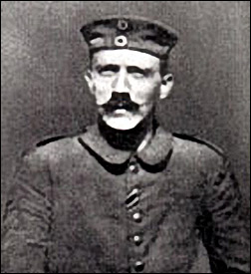
On 8 and 9 November 1923, Hitler staged the Nazi Beer Hall Putsch. He hoped to force the Bavarian government to work with the Nazis and march together on Berlin. The attempt failed but, although Hitler was tried for treason, the judge gave him a very light sentence.
While in prison, Hitler wrote 'Mein Kampf', which formulated his political ideas. He reorganised his party on his release from jail, but it was not until the world depression hit Germany that the Nazis were able to attract significant followers.
By 1930, the Nazis were polling around 6.5 million votes. In the presidential elections of 1932, Hitler came second. On 30 January 1933, President Hindenburg was forced to appoint Hitler as Chancellor, given his popular support.
In office, Hitler set about consolidating his power, appointing Nazis to government and gaining control of emergency powers. He eliminated all opposition, in the name of emergency control and, with the death of Hindenburg in 1934, Hitler's power was secured.
Hitler put Germany's unemployed to work on a massive rearmament programme, using propaganda and manufacturing enemies, such as the Jews, to prepare the country for war. Initially, Hitler's actions were ignored by his powerful neighbours, as they believed appeasement was the only way to avoid a war.

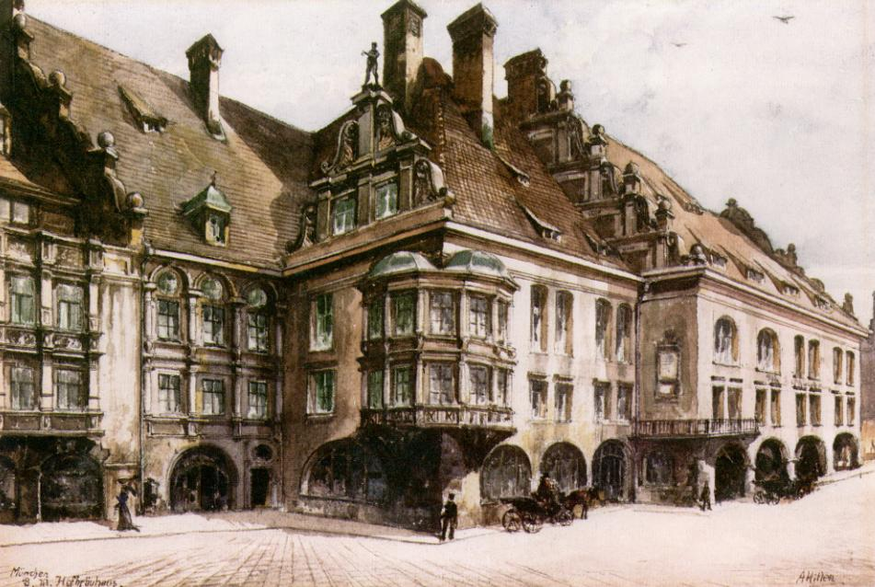

2. Early Beliefs as Expressed in Mien Kampf - Translated passages from Mein Kampf – A. Hitler

Fighting Jews as Defending God [p.60]
The Jewish doctrine of Marxism rejects the aristocratic principle of Nature and replaces the eternal privilege of power and strength by the mass of numbers and their dead weight. Thus it denies the value of personality in man, contests the significance of nationality and race, and thereby withdraws from humanity the premise of its existence and its culture. As a foundation of the universe, this doctrine would bring about the end of any order intellectually conceivable to man. And as, in this greatest of all recognizable organisms, the result of an application of such a law could only be chaos, on earth it could only be destruction for the inhabitants of this planet.
If, with the help of his Marxist creed, the Jew is victorious over the other peoples of the world, his crown will be the funeral wreath of humanity and this planet will, as it did thousands of years ago, move through the ether devoid of men.Hence today I believe that I am acting in accordance with the will of the Almighty Creator: by defending myself against the Jew, I am fighting for the work of the Lord

On the Weapons of the Jews [pp. 293-296]
His unfailing instinct in such things scents the original soul (die urspruengliche Seele) in everyone, and his hostility is assured to anyone who is not spirit of his spirit. Since the Jew is not the attacked but the attacker, not only anyone who attacks passes as his enemy, but also anyone who resists him. But the means with which he seeks to break such reckless but upright souls is not honest warfare, but lies and slander.
Here he stops at nothing, and in his vileness he becomes so gigantic that no one need be surprised if among our people the personification of the devil as the symbol of all evil assumes the living shape of the Jew.The ignorance of the broad masses about the inner nature of the Jew, the lack of instinct and narrow-mindedness of our upper classes, make the people an easy victim for this Jewish campaign of lies.
While from innate cowardice the upper classes turn away from a man whom the Jew attacks with lies and slander, the broad masses from stupidity or simplicity believe everything. The state authorities either cloak themselves in silence or, what usually happens, in order to put an end to the Jewish press campaign, they persecute the unjustly attacked, which, in the eyes of such an official ass, passes as the preservation of state authority and the safeguarding of law and order.
Slowly fear and the Marxist weapon of Jewry descend like a nightmare on the mind and soul of decent people.
With satanic joy in his face, the black-haired Jewish youth lurks in wait for the unsuspecting girl whom he defiles with his blood, thus stealing her from her people. With every means he tries to destroy the racial foundations of the people he has set out to subjugate. Just as he himself systematically ruins women and girls, he does not shrink back from pulling down the blood barriers for others, even on a large scale. It was and it is Jews who bring the Negroes into the Rhineland, always with the same secret thought and clear aim of ruining the hated white race by the necessarily resulting bastardization, throwing it down from its cultural and political height, and himself rising to be its master.
For a racially pure people which is conscious of its blood can never be enslaved by the Jew. In this world he will forever be master over bastards and bastards alone.
And so he tries systematically to lower the racial level by a continuous poisoning of individuals. And in politics he begins to replace the idea of democracy by the dictatorship of the proletariat.

3. Hitler’s 25 Points and the Basis for the National Socialist German Workers Party
Hitler’s 25 Points - 1920
TRANSLATION OF DOCUMENT 1708-PS
Edited by: Dr. Robert Ley
Published by: Central Publishing House of the N.S.D.A.P.
Franz Eher, successor Munich
The program of the NSDAP
The program is the political foundation of the NSDAP and accordingly the primary political law of the State. It has been made brief and clear intentionally.
All legal precepts must be applied in the spirit of the party program.
Since the taking over of control, the Fuehrer has succeeded in the realization of essential portions of the Party program from the fundamentals to the detail.
The Party Program of the NSDAP was proclaimed on the 24 February 1920 by Adolf Hitler at the first large Party gathering in Munich and since that day has remained unaltered. Within the national socialist philosophy is summarized in 25 points:
1. We demand the unification of all Germans in the Greater Germany on the basis of the right of self-determination of peoples.
2. We demand equality of rights for the German people in respect to the other nations; abrogation of the peace treaties of Versailles and St. Germain.
3. We demand land and territory (colonies) for the sustenance of our people, and colonization for our surplus population.
4. Only a member of the race can be a citizen. A member of the race can only be one who is of German blood, without consideration of creed. Consequently no Jew can be a member of the race.
5. Whoever has no citizenship is to be able to live in Germany only as a guest, and must be under the authority of legislation for foreigners.
6. The right to determine matters concerning administration and law belongs only to the citizen. Therefore we demand that every public office, of any sort whatsoever, whether in the Reich, the county or municipality, be filled only by citizens. We combat the corrupting parliamentary economy, office-holding only according to party inclinations without consideration of character or abilities.
7. We demand that the state be charged first with providing the opportunity for a livelihood and way of life for the citizens. If it is impossible to sustain the total population of the State, then the members of foreign nations (non-citizens) are to be expelled from the Reich.
8. Any further immigration of non-citizens is to be prevented. We demand that all non-Germans, who have immigrated to Germany since the 2 August 1914, be forced immediately to leave the Reich.
9. All citizens must have equal rights and obligations.
10. The first obligation of every citizen must be to work both spiritually and physically. The activity of individuals is not to counteract the interests of the universality, but must have its result within the framework of the whole for the benefit of all Consequently we demand:
11. Abolition of unearned (work and labour) incomes. Breaking of rent-slavery.
12. In consideration of the monstrous sacrifice in property and blood that each war demands of the people personal enrichment through a war must be designated as a crime against the people. Therefore we demand the total confiscation of all war profits.
13. We demand the nationalization of all (previous) associated industries (trusts).
14. We demand a division of profits of all heavy industries.
15. We demand an expansion on a large scale of old age welfare.
16. We demand the creation of a healthy middle class and its conservation, immediate communalization of the great warehouses and their being leased at low cost to small firms, the utmost consideration of all small firms in contracts with the State, county or municipality.
17. We demand a land reform suitable to our needs, provision of a law for the free expropriation of land for the purposes of public utility, abolition of taxes on land and prevention of all speculation in land.
18. We demand struggle without consideration against those whose activity is injurious to the general interest. Common national criminals, usurers, Schieber and so forth are to be punished with death, without consideration of confession or race.
19. We demand substitution of a German common law in place of the Roman Law serving a materialistic world-order.
20. The state is to be responsible for a fundamental reconstruction of our whole national education program, to enable every capable and industrious German to obtain higher education and subsequently introduction into leading positions. The plans of instruction of all educational institutions are to conform with the experiences of practical life. The comprehension of the concept of the State must be striven for by the school [Staatsbuergerkunde] as early as the beginning of understanding. We demand the education at the expense of the State of outstanding intellectually gifted children of poor parents without consideration of position or profession.
21. The State is to care for the elevating national health by protecting the mother and child, by outlawing child-labor, by the encouragement of physical fitness, by means of the legal establishment of a gymnastic and sport obligation, by the utmost support of all organizations concerned with the physical instruction of the young.
22. We demand abolition of the mercenary troops and formation of a national army.
23. We demand legal opposition to known lies and their promulgation through the press. In order to enable the provision of a German press, we demand, that: a. All writers and employees of the newspapers appearing in the German language be members of the race: b. Non-German newspapers be required to have the express permission of the State to be published. They may not be printed in the German language: c. Non-Germans are forbidden by law any financial interest in German publications, or any influence on them, and as punishment for violations the closing of such a publication as well as the immediate expulsion from the Reich of the non-German concerned. Publications which are counter to the general good are to be forbidden. We demand legal prosecution of artistic and literary forms which exert a destructive influence on our national life, and the closure of organizations opposing the above made demands.
24. We demand freedom of religion for all religious denominations within the state so long as they do not endanger its existence or oppose the moral senses of the Germanic race. The Party as such advocates the standpoint of a positive Christianity without binding itself confessionally to any one denomination. It combats the Jewish-materialistic spirit within and around us, and is convinced that a lasting recovery of our nation can only succeed from within on the framework: common utility precedes individual utility.
25. For the execution of all of this we demand the formation of a strong central power in the Reich. Unlimited authority of the central parliament over the whole Reich and its organizations in general. The forming of state and profession chambers for the execution of the laws made by the Reich within the various states of the confederation. The leaders of the Party promise, if necessary by sacrificing their own lives, to support by the execution of the points set forth above without consideration.
Source:
Nazi Conspiracy and Aggression Volume IV
Office of the United States Chief Counsel for Prosecution of Axis Criminality
Washington, DC : United States Government Printing Office, 1946

4. Hitler’s Use of Propaganda
Read the translated passage from Hitler’s Mien Kampf and carefully examine the examples of propaganda implemented during his time in power.

In the space on your chart, summarizer Hitler’s view of propaganda and record your observations after viewing the samples. Do you think he was successful based on what you see and what you already know?
On the Use of Propaganda – Excerpt from Mien Kampf
The function of propaganda does not lie in the scientific training of the individual, but in calling the masses' attention to certain facts, processes, necessities, etc., whose significance is thus for the first time placed within their field of vision ...
All propaganda must be popular and its intellectual level must be adjusted to the most limited intelligence among those it is addressed to. Consequently, the greater the mass it is intended to reach, the lower its purely intellectual level will have to be. But if, as in propaganda for sticking out a war, the aim is to influence a whole people, we must avoid excessive intellectual demands on our public, and too much caution cannot be extended in this direction.
The more modest its intellectual ballast, the more exclusively it takes into consideration the emotions of the masses, the more effective it will be. And this is the best proof of the soundness or unsoundness of a propaganda campaign, and not success pleasing a few scholars or young aesthetes.
The art of propaganda lies in understanding the emotional ideas of the great masses and finding, through a psychologically correct form, the way to the attention and thence to the heart of the broad masses.
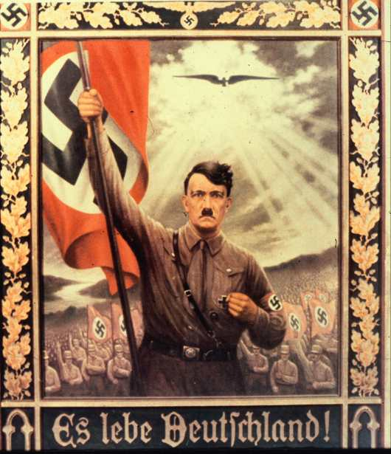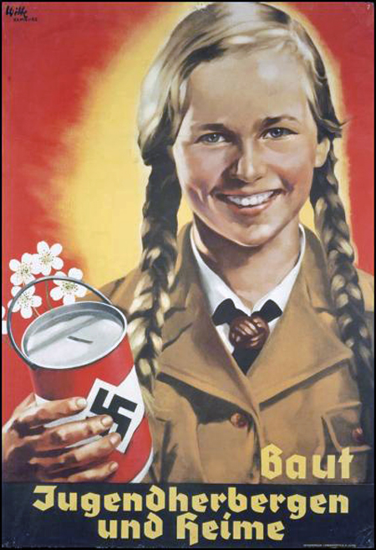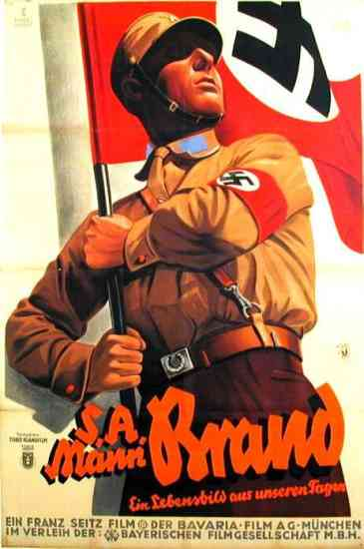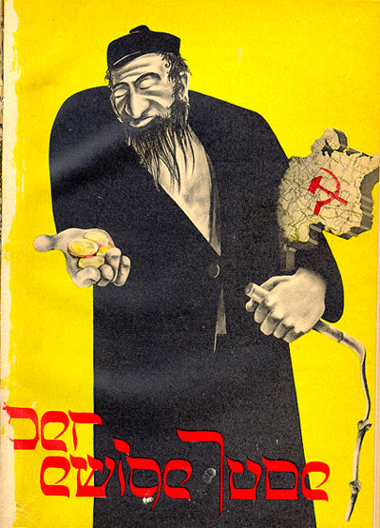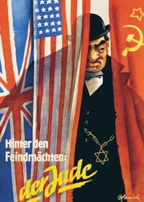

5. Hitler and the German Economy
Germany’s economy was in a mess when Hitler was elected Chancellor in January 1933. Hitler and Nazi propaganda had played on the population’s fear of no hope. Unemployment peaked at 6 million during the final days of the Weimar Republic – near enough 33% of the nation’s working population. Now Hitler decreed that all should work in Nazi Germany and he constantly played on the economic miracle Nazi Germany achieved.
This "economic miracle" was based on unemployment all but disappearing by 1939.
Unemployment in Germany | Total
January 1933 | 6 million
January 1934 | 3.3 million
January 1935 | 2.9 million
January 1936 | 2.5 million
January 1937 | 1.8 million
January 1938 | 1.0 million
January 1939 | 302,000
But was this true or did the Nazi propaganda machine move into overdrive to persuade the nation and Europe that she had achieved something that other European nations had not during the time of economic depression?
A number of policies were introduced which caused the unemployment figures to drop.
Women were no longer included in the statistics so any women who remained out of work under the Nazi’s rule did not exist as far as the statistics were concerned.
The unemployed were given a very simple choice: do whatever work is given to you by the government or be classed as "work-shy" and put in a concentration camp.
Jews lost their citizenship in 1935 and as a result were not included in unemployment figures even though many lost their employment at the start of Hitler’s time in power.
Many young men were taken off of the unemployment figure when conscription was brought in (1935) and men had to do their time in the army etc. By 1939, the army was 1.4 million strong. To equip these men with weapons etc., factories were built and this took even more off of the unemployment figure.
With these measures in place the unemployment figure had to fall drastically and many saw the Nazi figures as nothing more than a book-keeping trick. However, many would have been too scared to speak out against the Nazis or pass negative comments on the published figures - such was the fear of the Gestapo.
However, there is no doubt that work was created. The Nazis introduced public work schemes for men who worked in the National Labour Service (Reichsarbeitsdienst or RAD). Their work would have included digging ditches on farms to assist irrigation, building the new autobahns, planting new forests etc. The men of the RAD wore a military style uniform, lived in camps near to where they were working and received only what we would term pocket money. However, compared to the lack of success of the Weimar government and the chronic misery of 1931 to 1932, these men felt that at least the Nazi government was making the effort to improve their lot.
To ‘protect’ those in work, the German Labour Front was set up. This was led by Robert Ley. The GLF took the role of trade unions which had been banned. To an extent, the GLF did this. Ley ordered that workers could not be sacked on the spot but he also ordered that a worker could not leave his job without the government’s permission. Only government labour exchanges could arrange for a new job if someone did leave his employment.
However, the GLF increased the number of hours worked from 60 to 72 per week (including overtime) by 1939. Strikes were outlawed. The average factory worker was earning 10 times more than those on dole money and few complained – though to do so was fraught with potential difficulties.
The leisure time of the workers was also taken care of. An organisation called "Kraft durch Freude" (KdF) took care of this. Ley and the KdF worked out that each worker had 3,740 hours per year free for pursuing leisure activities - which the state would provide. The activities provided by the state were carefully and systematically recorded. For the Berlin area (1933-38) :
Type of Event | Number of events | Number of people involved
Theatre performances | 21,146 | 11,507,432
Concerts | 989 | 705,623
Hikes | 5,896 | 126,292
Sports Events | 388 | 1,432,596
Cultural events | 20,527 | 10,518,282
Holidays and cruises | 1,196 | 702,491
Museum tours | 61,503 | 2,567,596
Exhibitions | 93 | 2,435,975
Week-end trips | 3,499 | 1,007,242
Courses/Lectures at the German Adult Education Office | 19,060 | 1,009,922
Cheap holidays and the offer of them was a good way to win the support of the average person in the street. A cruise to the Canary Islands cost 62 marks - easily affordable to many though most cruises were taken up by Nazi Party officials. Walking and skiing holidays in the Bavarian Alps cost 28 marks. A two-week tour of Italy cost 155 marks.
The KdF also involved itself in introducing a scheme whereby the workers could get a car. The Volkswagen - People's Car - was designed so that most could afford it. The Beetle, designed by Ferdinand Porsche, cost 990 marks. This was about 35 weeks wages for the average worker. To pay for one, workers went on a hire purchase scheme. They paid 5 marks a week.

6. Putting Ideologies into Action
At the annual party rally held in Nuremberg in 1935, the Nazis announced new laws which institutionalized many of the racial theories prevalent in Nazi ideology. The laws excluded German Jews from Reich citizenship and prohibited them from marrying or having sexual relations with persons of "German or related blood." Ancillary ordinances to the laws disenfranchised Jews and deprived them of most political rights.
The Nuremberg Laws, as they became known, did not define a "Jew" as someone with particular religious beliefs. Instead, anyone who had three or four Jewish grandparents was defined as a Jew, regardless of whether that individual identified himself or herself as a Jew or belonged to the Jewish religious community. Many Germans who had not practiced Judaism for years found themselves caught in the grip of Nazi terror. Even people with Jewish grandparents who had converted to Christianity were defined as Jews.
For a brief period after Nuremberg, in the weeks before and during the 1936 Olympic Games held in Berlin, the Nazi regime actually moderated its anti-Jewish attacks and even removed some of the signs saying "Jews Unwelcome" from public places. Hitler did not want international criticism of his government to result in the transfer of the Games to another country. Such a loss would have been a serious blow to German prestige.
After the Olympic Games (in which the Nazis did not allow German Jewish athletes to participate), the Nazis again stepped up the persecution of German Jews. In 1937 and 1938, the government set out to impoverish Jews by requiring them to register their property and then by "Aryanizing" Jewish businesses. This meant that Jewish workers and managers were dismissed, and the ownership of most Jewish businesses was taken over by non-Jewish Germans who bought them at bargain prices fixed by Nazis. Jewish doctors were forbidden to treat non-Jews, and Jewish lawyers were not permitted to practice law.
Like everyone in Germany, Jews were required to carry identity cards, but the government added special identifying marks to theirs: a red "J" stamped on them and new middle names for all those Jews who did not possess recognizably "Jewish" first names -- "Israel" for males, "Sara" for females. Such cards allowed the police to identify Jews easily.

