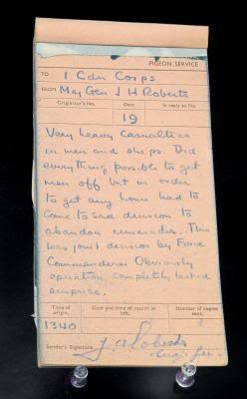

This message was written by Major-General J.H. Roberts at 13:40, August 19, 1942 and sent back to England by carrier pigeon. It reads:
"Very heavy casualties in men and ship. Did everything possible to get men off but in order to get any home had to come to sad decision to abandon remainder. Obviously operation completely lacked surprise."

Task
Read the artifact with your groups and answer the following questions on your Archives handout

- What in this message indicates a feeling of desperation?
- What in this message indicates a feeling of frustration?
- Do you feel an artifact like this should be considered a Canadian treasure and displayed for future generations to see?
(Consider its historical value vs. the reminder of a great day of tragedy)
“At Hong Kong on the morning of the 19th December, 1941, a Company of the Winnipeg Grenadiers to which Company-Sergeant-Major Osborn belonged, became divided during an attack on Mount Butler, a hill rising steeply above sea level. A part of the Company led by Company-Sergeant-Major Osborn captured the hill at the point of the bayonet and held it for three hours when, owing to the superior numbers of the enemy and to fire from an unprotected flank, the position became untenable. Company-Sergeant-Major Osborn and a small group covered the withdrawal and when their turn came to fall back Osborn, single-handed, engaged the enemy while the remainder successfully joined the Company. Company-Sergeant-Major Osborn had to run the gauntlet of heavy rifle and machine gun fire. With no consideration for his own safety he assisted and directed stragglers to the new Company position, exposing himself to heavy enemy fire to cover their retirement. Wherever danger threatened he was there to encourage his men.
During the afternoon the Company was cut off from the Battalion and completely surrounded by the enemy who were able to approach to within grenade throwing distance of the slight depression which the Company were holding. Several enemy grenades were thrown which Company-Sergeant-Major Osborn picked up and threw back. The enemy threw a grenade which landed in a position where it was impossible to pick it up and return it in time. Shouting a warning to his comrades this gallant Warrant Officer threw himself on the grenade which exploded killing him instantly. His self-sacrifice undoubtedly saved the lives of many others.
Company-Sergeant-Major Osborn was an inspiring example to all throughout the defence which he assisted so magnificently in maintaining against an overwhelming enemy force for over eight and a half hours, and in his death he displayed the highest qualities of heroism and self-sacrifice.”
(London Gazette, no.37517, 2 April 1946)

