Neals____________________CHV 2O _-_Charter of rights & freedoms_______due Date: **AT THE END OF CLASS!**

**Charter of Rights and Freedoms Poster Assignment**

**Learning Goal:** To describe the rights and freedoms guaranteed to Canadians in schools, communities, and the nation.

Now that you understand clearly that democratic "rights" bring with them responsibilities, you are to create a visual poster titled ***Canadian Charter of Rights and Freedoms.***



Once you have completed your organizer, you will create a poster using the App on the IPads.

Your poster will be submitted for evaluation and should include the following:

* Identify and list what you believe to be the **FOUR** most important rights and freedoms provided to citizens in Canada.
* For each right listed, include an appropriate visual image that symbolizes that democratic right.
* For each of the **FOUR** rights you have chosen, you will include a brief explanation for why you believe it is one of the most important rights and freedoms.
* For each of the **FOUR** rights you have chosen, you must give a real life example where an individual’s rights were either upheld or restricted.
* You must also choose a right to eliminate and create one to replace it. Are there any you feel are outdated or do not address rights and freedoms equally?
* **Share with ME!** Creativity and originality in design and layout should be evident. Your display should capture your viewer's attention and provoke thought.

**Example:** (**NOTE:** You will do this for **4** different rights!)

**Democratic Right:** **3.** Every citizen of Canada has the right to vote in an election of members of the House of Commons or of a legislative assembly and to be qualified for membership therein.



I feel this is one of the most important rights in the Charter of Rights and Freedoms. We would not be a democracy if we did not have the right to vote. Voting allows us all to have equal say, provides us with the right to participate in government and be active citizens.

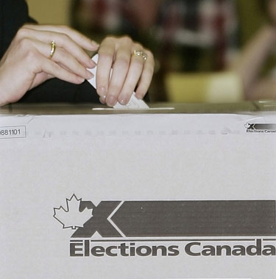

An example of a restriction of rights and freedoms is that women and visible minorities did not always have the right to vote in Canada. Now ALL citizens over 18 have that **RIGHT** (including inmates)**.**

**Charter of Rights and Freedoms – Popplet Rubric**

Name(s):_____________________________________________

|  |  |  |  |  |  |
| --- | --- | --- | --- | --- | --- |
| Categories | Level 1  (50 -59%) | Level 2  (60 - 69%) | Level 3  (70 -79%) | Level 4  (80 -100%) | Total |
| **Knowledge and**  **Understanding**  - Understanding of rights and  Responsibilities  /10 | demonstrates  limited understanding of rights and  responsibilities | demonstrates  some  understanding of rights and  responsibilities | demonstrates  considerable  understanding of rights and  responsibilities | demonstrates  thorough  understanding of rights and  responsibilities |  |
| **Thinking and Inquiry**  Uses critical and  creative thinking  process in  connecting rights and responsibilities to real life situations  /10 | uses critical/ creative thinking skills with limited  effectiveness | uses critical/ creative thinking skills with some  effectiveness | uses critical/ creative thinking skills with considerable  effectiveness | uses critical/ creative thinking skills with a high  degree of  effectiveness |  |
| **Communication**  Expression and  organization of ideas and information about rights and  responsibilities in written and visual forms  /10 | expresses and  organizes ideas  and information  with limited  effectiveness | expresses and  organizes ideas  and information  with some  effectiveness | expresses and  organizes ideas  and information  with considerable  effectiveness | expresses and  organizes ideas  and information  with a high  degree of  effectiveness |  |
| **Application**  Transfer of  knowledge about rights and  responsibilities to a new context  /10 | transfers  knowledge about rights and  responsibilities  to a new context with limited  effectiveness   * Less than 2 rights identified | transfers  knowledge about rights and  responsibilities  to a new context  with some  effectiveness   * 2-3 rights identified | transfers  knowledge about rights and  responsibilities to a new context  with considerable  effectiveness   * 4 rights identified | Transfers knowledge about rights and  responsibilities to a new context  with a high degree of effectiveness   * 5 rights identified |  |

* Has included **FOUR** rights and freedoms
* Has included an explanation for why each right and freedom is one of the most important
* Has included a real life example
* Has included an image for each one.

**NEXT STEPS:**