Please Vote For Me!

(The greatest video about democracy in the world!)

* 1. Which child would you vote for and why?
  2. Were the processes used to select the monitors democratic?
  3. What aspects of the film mirrored democracy in action?
  4. Was the effort of running the election worthwhile for the students involved?
  5. What was the role the teacher and parents played in this film?
  6. Do children fully understand democratic principles at an early age?  
     Explain your answer.
  7. Were you surprised by any of the behaviour on the part of the children? Please explain.

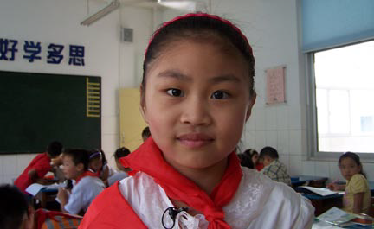

Cheng Cheng Xu Xiaofei Luo Lei