Monday | Tuesday | Wednesday | Thursday | Friday
31  Intro to Shakespeare and Othello | 1  Racism  Act I, Scene i | 2  The many faces of Iago  I, ii-iii | 3  II, i-ii | 4  Comparison of films
7  II, iii | 8  III, i-iii | 9  Writing task/ character/passage analysis | 10  Writing task/ character/passage analysis | 11  III, iv
14  IV, i-ii | 15  III, iv | 16  IV, i-ii | 17  IV, iii – V, ii | 18  PD DAY
21  Analysis | 22  Analysis | 23  Analysis | 24  Final Test | 25  Finish Film
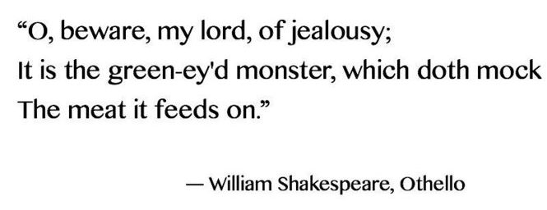
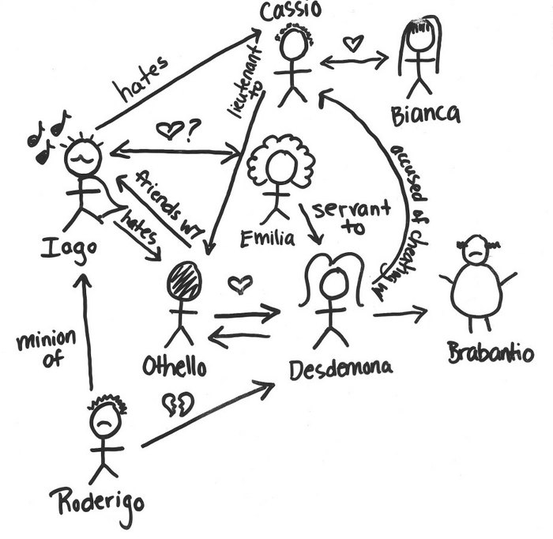
ENG 4CR Othello

