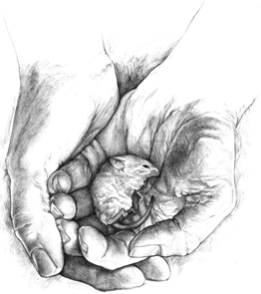

April – Of Mice and Men
Monday | Tuesday | Wednesday | Thursday | Friday
 |  |  | 6  Start OMAM  Intro note and discussion | 7  Snow Day!
10  Chapter #1 | 11  Chapter #2 | 12  Chapter #3  (LONG) | 13  Chapter #4 | 14  Good Friday
17  Easter Monday | 18  Chapter #5 | 19 (I’m away)  Note/Film | 20  “To a Mouse…”  Chapter #6 | 21  Character Sketch Assignment
24 (I’m Away)  Character Sketch | 25 (I’m Away)  OMAM Test Review/Character Sketch/Film | 26 (I’m Away)  OMAM Test Review/Character Sketch/Film | 27  OMAM Final Test | 28  Start And Then There Were None Murder Mystery genre

