Literal | Metaphorical | Key Quotation
Piggy’s Glasses | These represent the voice of reason and logic among the boys. They remind us of intelligence and clear-sightedness. They solve problems particularly by bringing fire (the fire of knowledge?) to the island.
The Island
The Conch
The Beast
Face Paint
Fire/Smoke
The Parachute Man
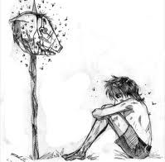
Metaphors in Lord of the Flies

