**Europe 1914**

**Kaiser Wilhelm II**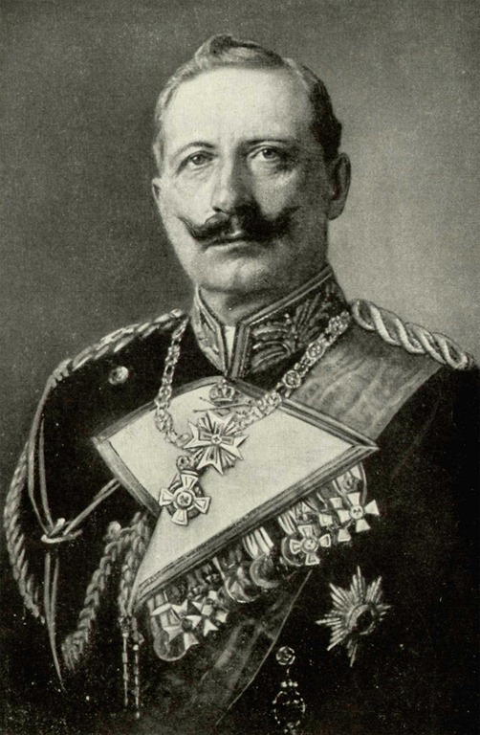

### Czar Nicholas II http://www.thehistoryblog.com/wp-content/uploads/2013/02/Tsar-Nicholas-II.jpg

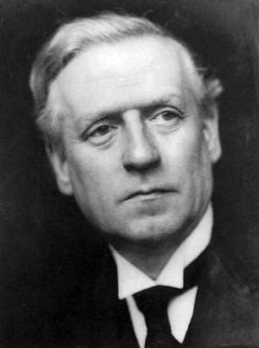**HH Asaquith to 1916,**

**David Lloyd George from 1916 to end of War** 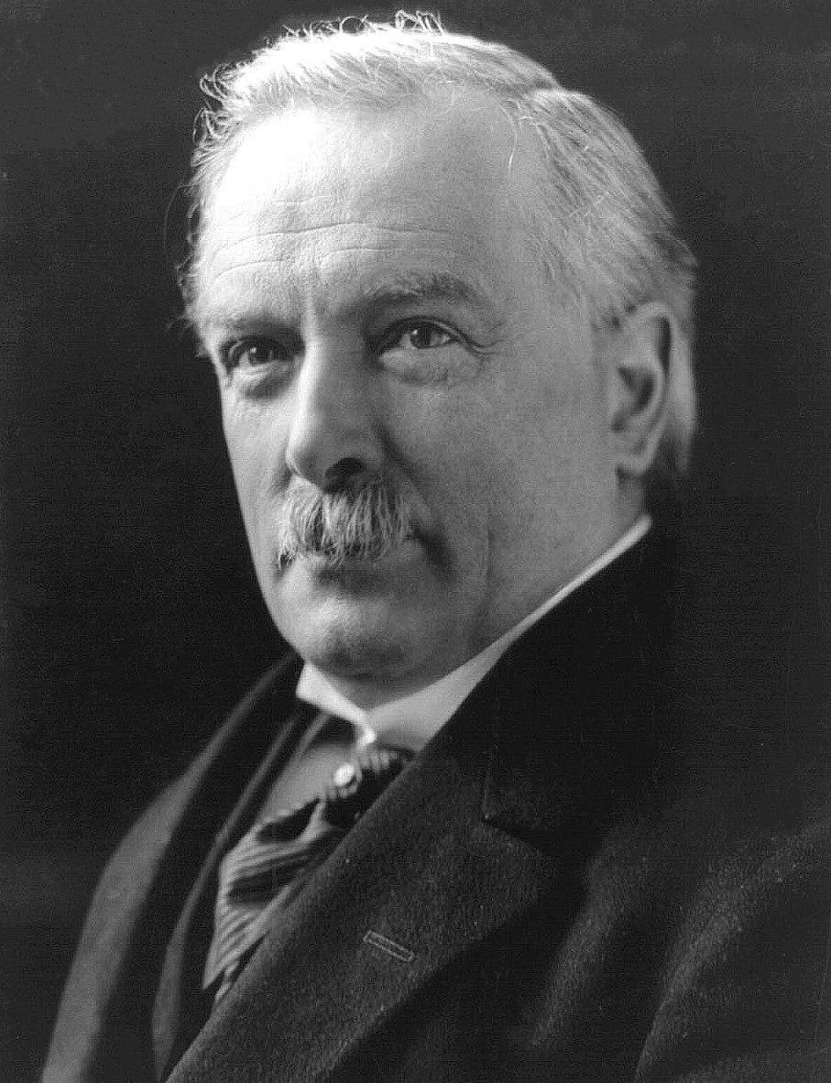

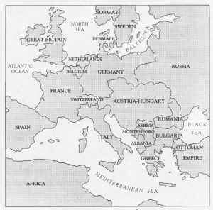

**Emperor Franz Josef**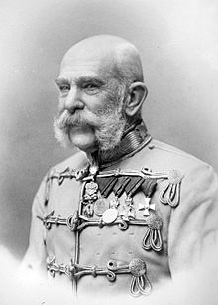

### President Raymond Poincare https://encrypted-tbn0.gstatic.com/images?q=tbn:ANd9GcQWnAX7xg2YBlVcvA80h6EC4Dqo3DYCjqq5nEU_Deo5Mn3IiWAx

### PhotoArchduke Franz Ferdinand, heir to the Austrian Throne

### 

* **Triple Alliance**
* **Triple Entente**