LEARNING STATION #1 - Movies
Instructions:
- Read the information below on Movies and Mary Pickford from the 1920s.
- Watch the video of Mary Pickford in PollyAnna (1920). What do you notice about the film? How does the plot flow?
- Watch The Love Parade (1929).
THE FILM INDUSTRY:
Films really blossomed in the 1920s, expanding upon the foundations of film from earlier years. Most US film production at the start of the decade occurred in or near Hollywood on the West Coast. By the mid-20s, movies were big business (with a capital investment totalling over $2 billion). By the end of the decade, there were 20 Hollywood studios, and the demand for films was greater than ever.
Throughout most of the decade, silent films were the predominant product of the film industry, having evolved from vaudevillian roots. But the films were becoming bigger (or longer), costlier, and more polished. They were being manufactured, assembly-line style, in Hollywood's 'entertainment factories,' in which production was broken down and organized into its various components (writing, costuming, makeup, directing, etc.).
By the end of the decade movies were now being made with sound. They were called “Talkies.” This was a revolutionary invention that changed the way we watch movies today!
EXAMPLE OF A CANADIAN MOVIE STAR 1920s
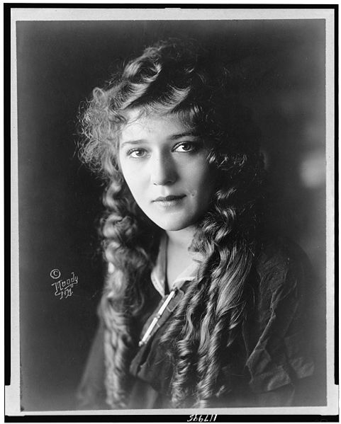 | Mary Pickford (April 8, 1892 – May 29, 1979) was a Canadian-born motion picture actress, co-founder of the film studio United Artists and one of the original 36 founders of the Academy of Motion Picture Arts and Sciences. Known as "America's Sweetheart," "Little Mary" and "The girl with the curls," she was one of the Canadian pioneers in early Hollywood and a significant figure in the development of film acting.  Because her international fame was triggered by moving images, she is a watershed figure in the history of modern celebrity. And as one of silent film's most important performers and producers, her contract demands were central to shaping the Hollywood industry. In consideration of her contributions to American cinema, the American Film Institute named Pickford 24th among the greatest female stars of all time.

Learning station #1: Movies
Polly Anna | The Love Parade
What are the differences between the first movie and the second?

Why was Mary Pickford important?
LEARNING STATION #2 – Fashion
Instructions:
- Look through the Fashion of the 1920s PowerPoint presentation.
- While you are going through this fill out the corresponding chart on your worksheet comparing the fashion of the 1920s with the fashion of today.
For young women, the “flapper look” was in. A flapper was a young woman who dressed outrageously. In winter, she wore galoshes with buckles unfastened to create the greatest possible flap. Hemlines rose about the knees and silk stockings were rolled down. Long hair was cut and set in a short “bobbed” style. Flappers liked to have fun in ways that would have been unthinkable for women in the past. They drove cars, did the Charleston (a fast-paced dance to loud jazz music), and even smoked cigarettes- a habit that was frowned upon because it was seen as unladylike. Fashions for a young man were often as outrageous. He sported baggy pants or knickers, a bright snappy hat, and a bowtie. His hair was greased down and parted in the middle to imitate the popular movie idols of the day. While these fashions were the latest craze, they did not reflect day-to-day life for most Canadian women and men. Most Canadians admired from afar those daring and wealthy enough to wear these latest fashions.

Learning station #2: Fashion
FASHION OF THE 1920S  NOTES | FASHION TODAY  NOTES | THOUGHTS ABOUT THE DIFFERENCES

LEARNING STATION #3- MUSIC OF THE 1920S
Instructions:
- Read the information below on music from the 1920s.
- Listen to the Duke At The Cotton Club.
- Watch the Video of Chicago - Nowadays_Hot Honey Rag. Notice that the two characters are dancing the Charleston, an iconic dance of the 1920s.
- Write down your first impression of this music? Can you see parallels to modern music in this music?
EARLY JAZZ
Jazz moved north from New Orleans in the United States and was made popular by such musicians as Duke Ellington and Louis Armstrong, both Black Americans. The dance of the decade- The Charleston- also emerged out of Black American culture. Its fast and wild pace quickly caught on with the high spirited young generation. The Boston City Council tried to have the dance banned, but it was here to stay. It became the emblem of the roaring “Jazz Age.” Black culture was enjoying a resurgence in the United States and its influences were felt in Canada. By the mid-1920s, jazz was being played in dance halls, roadhouses and speakeasies all over the country. Without early jazz, music today would not exist. Jazz inspired today’s music including rap, dance and rock!
Meanwhile, radio and phonograph records were bringing jazz to locations so remote that no band could reach them. And the music itself was beginning to change — an exuberant, collective music was coming to place more and more emphasis on the innovations of supremely gifted individuals. Improvising soloists, struggling to find their own voices and to tell their own stories, were about to take center stage.

EXAMPLES OF MUSICIAN’S OF THE TIME
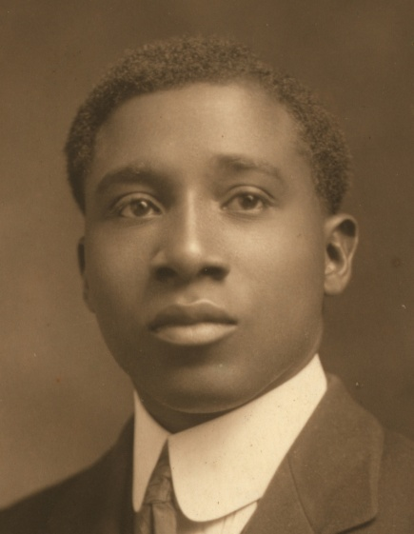 | Robert Nathaniel Dett (October 11, 1882 – October 2, 1943), often known as R. Nathaniel Dett, was a composer in the United States and Canada. During his lifetime he was one of the most successful black composers, known for his use of folk songs and spirituals for choral and piano compositions in the romantic style.  Dett was born in Drummondville, Ontario (now part of Niagara Falls, Ontario) where he studied piano at an early age showing initial interest at age three and formal piano lessons at age five. He was the son of Charlotte Washington Dett and Robert T. Dett; his mother was a native of Drummondville while his father was from the United States
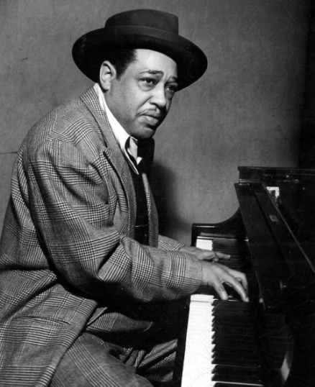 | Edward Kennedy "Duke" Ellington (April 29, 1899 – May 24, 1974) was a composer, pianist, and big band leader. Ellington wrote over 1,000 compositions  Due to his inventive use of the orchestra, or big band, and thanks to his eloquence and extraordinary charisma, he is generally considered to have elevated the perception of jazz to an art form on a par with other traditional genres of music.  Ellington's orchestra began its four-year residency at Harlem's famous Cotton Club in 1927, providing music for sumptuous stage routines in which exotically dressed black dancers performed for an exclusively white audience.
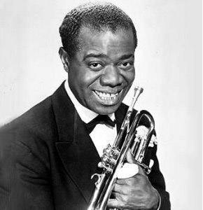 | Louis Daniel Armstrong (August 4, 1901 – July 6, 1971), nicknamed Satchmo or Pops, was an American jazz trumpeter and singer from New Orleans, Louisiana.  Coming to prominence in the 1920s as an "inventive" cornet and trumpet player, Armstrong was a foundational influence in jazz, shifting the music's focus from collective improvisation to solo performance  Note: You may know Louis Armstrong from his hit song “What a wonderful world”

Learning station #3: Music
Write down your first impression of this music (mood, feelings, instruments used, etc.)? Can you see parallels to modern music in this music?

LEARNING STATION #4 – Twenties talk
Instructions:
1. Read over the text below
2. “The Jazz Age Glossary” and fill in the 1920s Slang Crossword
3. Using “The Jazz Age Glossary” (NOT the scrapbook as the hand-out says) translate the sentences and complete the chart!
**blind pig- illegal drinking spot

Every Generation seems to have its own characteristic expressions or slang. “Cool” and “sweet” are just some of the slang words we use today. Slang refers to informal words or phrases. The expressions are often associated with a particular group and represent certain feelings or attitudes. When these feelings and attitudes change, slang expressions may pass out of use. Our language is always changing. Sometimes slang words become part of common usage and are entered into our formal dictionaries. Do you recognize any of these expressions from the 1920s? (See “The Jazz Age Glossary”)
Source: Cruxton, J. Bradley, et al. Spotlight Canada: Fourth Edition (Don Mills: Oxford University Press, 2000) p. 169.

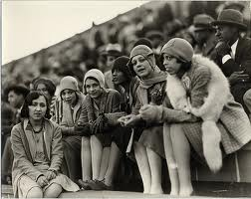
What could these girls be saying in “Twenties Talk”?

LEARNING STATION #5 – Art
Instructions:
1. Read the information below.
2. Study the Group of Seven paintings in the book “The Group of Seven and Tom Thompson”
3. Answer the questions provided!
The Group of Seven
Perhaps best known of all Canada’s artists, the Group of Seven came together in 1920 as an organization of “modern” painters. Throughout the 1920s members of the group painted Canada’s rugged northland in an interpretive style, using strong, deep colours. At the time people expected to see realistic, detailed landscape paintings. The Group of Seven took a different approach. The painted their impressions of what they saw in vivid light and shade that was unusual for the time – a kind of impressionism. Many Canadians were shocked by their bold, fresh style, and those who criticised this non-conformist type of painting called it the “hot mush school”; this referred to the bold colours and thick , heavy strokes of paint that were use on the canvases.
The original members of the Group of Seven – J.E.H. MacDonald, Lawren Harris, Franklin Carmichael, Arthur Lismer, F.H. Varley, A.Y. Jackson, and Franz Johnston – travelled in small groups in northern Ontario with their easels and sketch pads painting and sketching scenes of nature. They had similar styles and were influenced by their friend Tom Thompson who died in a mysterious boating accident in 1917. Thomson had helped to organize them as a group and three after his death they adopted the name Group of Seven.
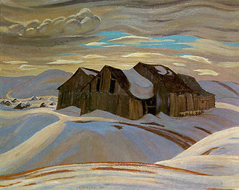
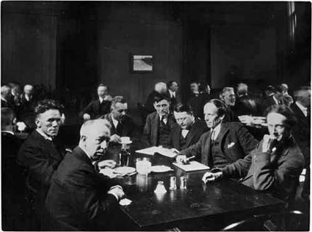
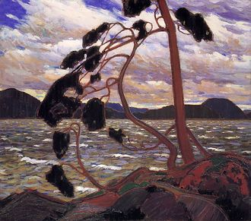
Other painters, like A.J. Casson, Emily Carr, and David Milne, also became famous for their beautiful impressions of the Canadian countryside. A whole new style of art emerged during the 1920s that was distinctly Canadian and added to an emerging sense of Canadian identity and nationalism. Today the paintings of the Group of Seven and other artists who painted at the same time and in the same style are highly valued. Canadians visit galleries and museums all over their country to enjoy these unique works of art that so clearly express Canada’s physical richness and beauty
Group of Seven Questions
- How do you think the Group of Seven’s paintings created a national style or identity for Canadian art in the 1920s? To answer the question, describe the subjects of the paintings and the moods they create.

- Do the landscape paintings of Thomson and the Group of Seven continue to reflect Canadian identity today? Explain your response, and if your answer is no, describe the subjects you would paint to capture Canada today.

LEARNING STATION #6 – Inventions that changed Canada
Radio:
The 1920s were radio’s best years. Everyone wanted to have a radio, and owning one was a status symbol. A good radio cost as much as a car, although handy individuals could make their own sets, called crystal sets, for a few dollars.
In the evenings, families gathered around the radio in the living room for entertainment. Radio programming included music, news, lectures, and concerts. A Saturday night hockey game (Hockey Night in Canada with Foster Hewitt) was first broadcast in February 1924.
One day, the afternoon announcer for Montreal’s CKAC showed up for work wearing a new hat. The on-air announcer asked, “where did you get that beautiful hat?” “In Michaud’s on Craig Street,” he replied. The next day, hundreds of orders for similar hats flooded Michaud’s. When the hat maker paid the station for similar “plugs,” radio advertising was born.
The invention of the radio helped Farmers and people in small towns not feel so isolated and politicians could speak directly to the public.
Radio connected people across the nation very quickly.
Question:
- What impact did Radio have on Canadian culture in the 1920s?

Automobiles:
Read the Following passage about Automobiles in the 1920s, and underline each example of how the invention changed life for Canadians:
Canada was the second most motorized nation in the world. In 1920, there was one car to every 22 Canadians. 10 years later there was one car for every 8 people. Three quarters of these cars were made by Ford, General Motors or Chrysler. Ford had been the first company to start making cars in Canada. Many Canadian families owned a Model-T Ford (nicknamed “Tin Lizzie.” The average Canadian selling price went from $900 in 1921 to $700 five years later.
These 1920s cars had to be hand-cranked to start, and they did not have a heater. Such luxuries as adjustable seats, brake lights, and foot pedals for acceleration were added later. Before anti-freeze was used, most people parked their cars for the winter and did not drive at all.
People could now get around much faster than ever before – automobiles travelled at a maximum of 64 km/hr. People wanted to drive, and they wanted to drive comfortably. This led to paved roads and highways for a smoother ride, and the spread of gas stations.
Above all else, cars brought mobility. Automobiles allowed farmers to come to town to shop and sell their goods and caused rapid growth of the Suburbs because people could live farther away from where they worked. It enabled friends and relatives to visit each other on a regular basis. The automobile made summer cottages more convenient and provided young people with more freedom to date whom they pleased.
The automobile revolutionized society. It changed people’s lifestyles, affected the layout of cities, replaced the corner store with larger city department stores, and caused traffic jams. To raise money to build roads, provinces charged license fees and placed a tax on gasoline.
Questions:
- What were the three most significant ways the automobile revolutionized life for Canadians?

Insulin:
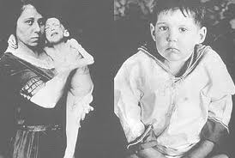
Canadian researchers contributed much in the field of medicine. Diabetics all over the world were given a new lease on life with the discovery of insulin by Doctors Fredrick Banting and Charles Best. Although not a cure for Diabetes, insulin stabilizes the blood sugar level for patients who suffer from the disease. Until insulin was made clinically available, a diagnosis of diabetes was an invariable death sentence, more or less quickly (usually within months, and frequently within weeks or days).

