The End of the War: The Last 100 Days

After 4 years it was still stalemate on the Western Front. Neither side could win any decisive battles to bring ultimate victory.
- 1917 Russia leaves the war due to a Revolution in their own country
- Germans are able to send all their forces to the Western Front.

1917 – The Americans Enter the War!!
The sinking of the Lusitania and the German policy of unrestricted warfare is what pulls them into the war.

Do you think they should have entered the war sooner?

1918 – Germany’s Last Attempt
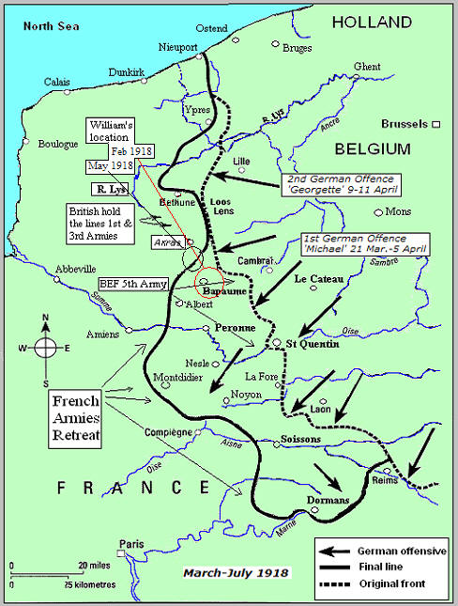
By the spring of 1918, Germany realized the policy of unrestricted submarine warfare did not force Britain to surrender as they had hoped. Also, Germany’s allies Austria-Hungary and Turkey were on the point of collapse. Germany knew they would have to make an effort to end the war soon. 1918, Germany launched a strong offensive on the Western Front before the U.S. could arrive.
- By July the German offensive failed without any real breakthrough.

The Allied Response

- In the Last 100 Days, the Entente moved 130km. The Canadians had a significant role in this effort.
- Hungry and tired, German soldiers surrendered to the Canadians and the Allies.
- By November 1918 , the Allies had pushed the Germans back almost to Germany and they called for an Armistice and peace talks to end the war.

The Last Shot of the War!
- The Armistice (an agreement to end the fighting) had been agreed on to begin on Nov. 11th, 1918 at 11 a.m.
- At 10:55 a.m., as Canadian troops walked through Belgium, a single German sniper fired a bullet killing Private George Price
- He was the last Canadian to be killed in the Great War

If Germany did not surrender, how much longer do you think the War would have lasted? Why? Provide specific examples and evidence.

