Justin Trudeau outrage at beheading of

Philippines hostage Ridsdel
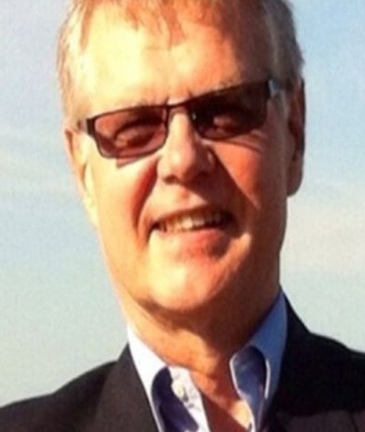
The Canadian Prime Minister Justin Trudeau has condemned the beheading of a Canadian hostage kidnapped by Islamist militants in the Philippines.
John Ridsdel, 68, was taken from a tourist resort with three others by the Abu Sayyaf group in September 2015.
In November, the Islamist militants released a video showing Mr Ridsdel and three other captives, and demanded a ransom of $80m (£55m).
Mr Trudeau called his death "an act of cold-blooded murder".
A Philippines army spokesman said Mr Ridsdel's severed head was found on the remote island of Jolo, hours after the Abu Sayyaf ransom deadline expired.
Mr Ridsdel was taken to Jolo after being kidnapped from a marina near the city of Davao, along with another Canadian, Robert Hall; a Norwegian, Kjartan Sekkingstad; and a Philippine woman, Mr Hall's girlfriend, Marites Flor. Mr Ridsdel later warned in a video released by the group that he was due to be killed on 25 April if no ransom was paid.
The Canadian government has a policy against paying ransoms.
Confirming the death of Mr Ridsdel, Mr Trudeau called it a "heinous act".
"Canada condemns without reservation the brutality of the hostage-takers, and this unnecessary death. This was an act of cold-blooded murder and responsibility rests squarely with the terrorist group who took him hostage," he said in a statement.

What is Abu Sayyaf?
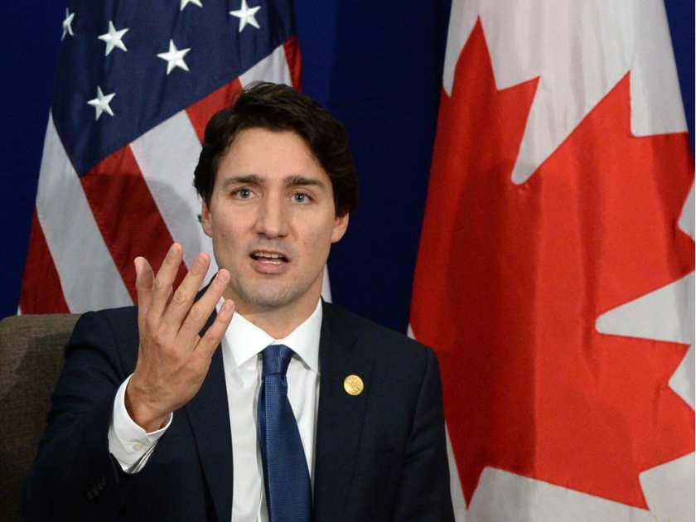
Abu Sayyaf is one of the smallest and most violent jihadist groups in the southern Philippines. Its name means "bearer of the sword" and it is notorious for kidnapping for ransom, and for attacks on civilians and the army.
In 2004 it bombed a ferry in Manila Bay, killing 116 people. It is currently holding at least four groups of hostages - a mix of Malaysian and Indonesian workers, Western tourists and one Filipina - and is being hunted by the army, which has vowed to defeat the group before the end of President Benigno Aquino's term in May.

The group is believed to have killed Canadian hostage John Ridsdel, 68, months after abducting him from a tourist resort.
One of smallest but most radical of Islamist separatist groups in southern Philippines, its name means "bearer of the sword" in Arabic.
It split from the larger Moro National Liberation Front in 1991. Membership is said to number in the low hundreds.

What does it want?
The group has been agitating for the creation of an independent Islamic state in predominantly Catholic Philippines, and uses tactics such as hostage-taking and bombings to pressure the government.
Several of its factions have pledged allegiance to the so-called Islamic State.

How dangerous is it?
Numerous Filipino and foreign civilians have been kidnapped in south Philippines and parts of neighbouring Malaysia over the decades, and used as hostages to extract ransoms.
Though some have been released after negotiations or attacks by Philippine forces, others have been murdered when demands were not met.
Abu Sayyaf has also said it carried out bombings in cities in the south and a ferry bombing in 2004 in Manila Bay that killed more than 100 people, considered one of the worst terror attacks in the Philippines.
Islamic State threat in Southeast Asia

"It's hard," a friend of Mr Ridsdel, Bob Rae, told CBC News. "It's just very hard. I've been involved behind the scenes for the last six months trying to find a solution and it's been very painful."
A former mining executive, Mr Ridsdel is described by Canadian media as semi-retired. He also worked as a journalist.
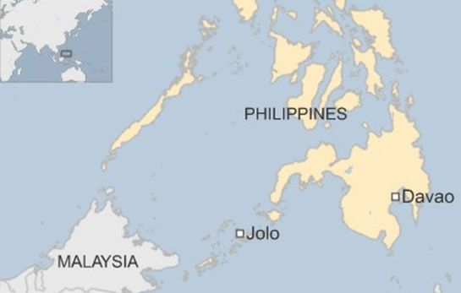
Abu Sayyaf was set up in the 1990s and received funding from al-Qaeda. It is fighting for an independent Islamic province in the Philippines.
Several of its factions have declared their allegiance to the militant group Islamic State. Abu Sayyaf is also holding several other foreigners.
Eighteen Philippine soldiers were killed in clashes with the militants on Basilan island near Jolo island earlier this month.

Questions:
- Why should you care about issues in your community and of global significance?
- What is your position on this issue? How is this influenced by your beliefs and values?
- How important a role do you think the media play in swaying public opinion on this issue?
- Do you think the Canadian government is justified in their stance on this issue? If not, how should the Canadian government evolve to accommodate more severe actions committed to Canadians globally?

