Japanese Canadian Internment Camps – CHC 2P

Background
- At the start of World War II, approximately _________________ people of Japanese descent lived in Canada, mostly in ____________________.
- 75% held ____________________________ and over 13,000 were Japanese-Canadians (they were _____________________________________).
- Most Japanese-Canadians were hard workers, owned land, and paid taxes.

Pearl Harbour
- Japan attacks Pearl Harbour (Hawaii) on Dec. 7th, 1941 in a surprise attack. The damage was extensive and took out most of the US force stationed there. This draws the USA into WWII.

Canada’s Response
- Canada declared __________________________ shortly after.
- The Japanese were ___________________________ of being ___________ as many were fisherman.
- The property of the Japanese-Canadians (land, business etc.) were _________________ by the __________________ and sold and the proceeds were used to pay for their _____________________.

Anti-Japanese Propaganda
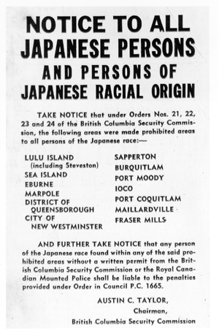
The Canadian Response

- The War Measures Act is once again brought in, stripping citizens of their ____________ to justify internment.
- By the end of 1942 more than 22,000 men, women, and children of Japanese ancestry were taken to the camps.
- Conditions were poor, men were forced into labour.
- Those unwilling to live in internment camps faced the possibility of ______________________________________.

After the War
- Japanese-Canadians who remained in Canada were not allowed to return to the BC coast until ________.
- Their homes and property _________________________!
- It was not until 1988 that a formal apology came from Canada’s government. The Canadian government also provided compensation, including $21,000 for survivors and restatement of their citizenship. Too late?
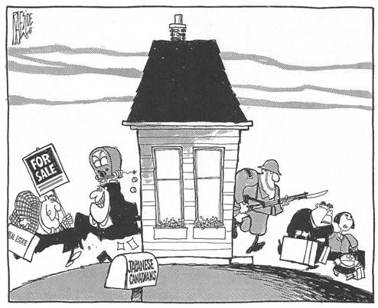
Explain what is happening in this political cartoon.

