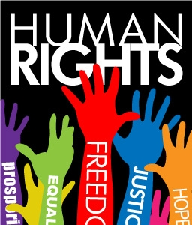
Human Rights

- Human rights are

- We are all equally entitled to our human rights without ___________________________.
- These rights are all interrelated, interdependent and indivisible.
- Universal human rights are often expressed and guaranteed by law, in the forms of treaties, customary international law, general principles and other sources of international law.
- International human rights law lays down __________________________________ in certain ways or to refrain from certain acts, in order to promote and protect human rights and fundamental freedoms of individuals or groups.

WHERE DO RIGHTS COME FROM?

WHAT IS THE UNITED NATIONS?
- The United Nations (UN) is an international organisation that was established in 1945, the year the Second World War ended.
- Its founders hoped it would be able to prevent catastrophes like the Holocaust from happening in the future.
- So promoting human rights became an aim of the UN, along with maintaining international peace and reducing poverty.

THERE ARE 30!

THESE ARE SOME OF THE RIGHTS:

1.
2.
3.
4.
5.
6.
7.
8.
9.
10.
11.
12.
13.
14.
15.
16.
17.
18.
19.

THE KEY MESSAGES OF THE UNIVERSAL DECLARATION ARE THAT HUMAN RIGHTS ARE:

HOW DOES THE UDHR PROTECT HUMAN RIGHTS?

HUMAN RIGHTS VIOLATIONS
- Human rights violations occur ___________________________________________________

________________________________________________ (including civil, political, cultural, social, and economic rights). Furthermore, violations of human rights can occur when any state or non-state actor breaches any part of the UDHR treaty or other international human rights or humanitarian law.

HUMAN RIGHTS ABUSE
- Human rights abuses are monitored by _______________________________________, national institutions and governments and by many independent non-governmental organizations, such as Amnesty International, International Federation of Human Rights, Human Rights Watch, World Organisation Against Torture, Freedom House, International Freedom of Expression Exchange and Anti-Slavery International.
- These organizations ______________________________________________________________

______________________________________________________________________________. Wars of aggression, war crimes and crimes against humanity, including genocide, are breaches of International humanitarian law and represent the most serious of human rights violations.
- The UN Security Council has interceded with peace keeping forces, and other states and treaties (NATO) have intervened in situations to protect human rights.

