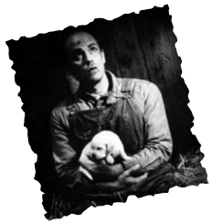
Power, Animals & the American Dream
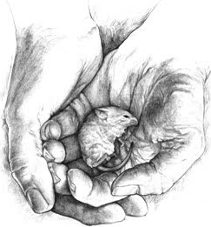
The Impossibility of the American Dream

The American Dream:
The term was first used by James Truslow Adams in his book The Epic of America which was written in 1931. He states:

"The American Dream is "that dream of a land in which life should be better and richer and fuller for everyone, with opportunity for each according to ability or achievement. It is not a dream of motor cars and high wages, but a dream of social order in which each man and each woman shall be able to achieve the fullest stature of which they are capable of, and be recognized by others for what they are, regardless of the circumstances of birth or position."

Their perfect world is one of independence. Workers like Lennie and George have no family, no home, and very little control over their lives. They have to do what the boss tells them and they have little to show for it. They only own what they can carry. Therefore, this idea of having such power over their lives is a strong motivation.

Dream #1: Independence

Dream #2: Leaving a Legacy

Dream #3: Lost Youth ~ Security & Innocence

Dream #4: Companionship

Power in Of Mice and Men – Curley vs Slim

Curley represents the vicious and belligerent way in which social power tends to manifest itself. Given Curley’s temperament, he serves as a natural foil (a character whose emotions or actions contrast with those of other characters) for both the gentle Lennie and the self-assured Slim.

Slim possesses a quiet competence that earns him the respect of everyone on the ranch. Like Curley, Slim stands as an authority figure. Curley’s strength, on the other hand, depends upon his ability to dominate and defeat those weaker than him.

Slim’s authority comes from his self-possession; he needs neither the approval nor the failure of others to confirm his stature.

Animals (and the weak)

Mice and Slim’s puppies are innocent and unknowing of their place in the world/society, similar to Lennie.

They represent the weakness and helplessness of animals. The fate of the puppies demonstrates what happens to the weak, non-contributing beings on the farm (and in society).

Candy’s dog represents the fate awaiting anyone who has outlived his or her purpose. Once a fine sheepdog, useful on the ranch, Candy’s mutt is now debilitated by age.

Candy’s sentimental attachment to the animal—his plea that Carlson let the dog live for no other reason than that Candy raised it from a puppy—means nothing at all on the ranch.

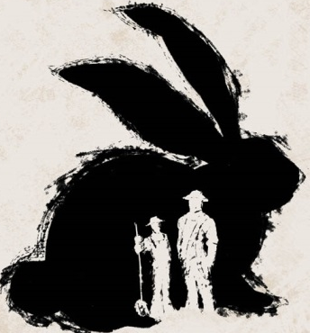
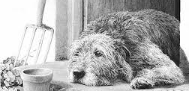
Although Carlson promises to kill the dog painlessly, his insistence that the old animal must die supports a cruel natural law that the strong will dispose of the weak. Candy internalizes this lesson, for he fears that he himself is nearing an age when he will no longer be useful at the ranch, and therefore no longer welcome.

