

**The Details:**

December 6, ____________________ dawned clear and sunny in ___________. With a population of about 50,000, it was the largest city in Atlantic Canada.

Before darkness fell, more than _____________ people would __________, with another ___________ to follow.

______________ more would be injured in the biggest _______________ the world had ever seen.

Halifax was booming. It was a ________________ town in 1917 and World War 1 had been going on for 3 years. Halifax has one natural asset – one of the world’s _________________ ______________ which made it important for the war effort at home.

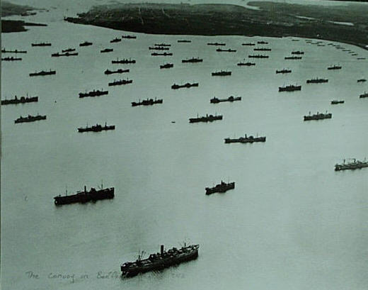

It had never been so busy because ships were carrying _____________, ______________ and _______________. The twentieth century had brought miracles of ______________ ________________.

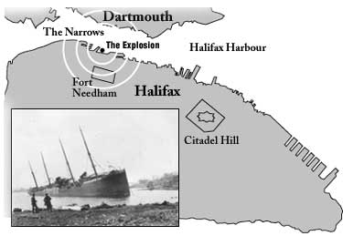

The ___________________ was part of daily life. A _________________ that moved around the world, door to door in mere hours, was still an amazing accomplishment in 1917.

_____________________ were catching on. They weren't considered basic appliances and not many people had them.

**[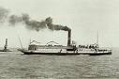](http://images.google.ca/imgres?imgurl=http://www.simplonpc.co.uk/CGN/MontBlanc2-03.jpg&imgrefurl=http://www.simplonpc.co.uk/CGN1.html&h=299&w=450&sz=31&hl=en&start=1&um=1&tbnid=AEXw8MAdgw-wpM:&tbnh=84&tbnw=127&prev=/images?q%3Dmont%2Bblanc%2Bship%26svnum%3D10%26um%3D1%26hl%3Den)**

**The Mont Blanc**

The Mont Blanc left _________ ___________ and was heading to Halifax. It flew no flags _____________ of its _____________: a ship laden( ) with _____________ would be a prime ______________for German attack. German attacks on supply ships was very common. Typically ships going across the ______________ had a _____________ of military ships __________________ them.

**[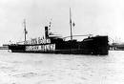](http://images.google.ca/imgres?imgurl=http://hoover.archives.gov/exhibits/collections/flour%20sacks/images/1915-036.jpg&imgrefurl=http://hoover.archives.gov/exhibits/collections/flour%20sacks/index.html&h=337&w=500&sz=42&hl=en&start=5&um=1&tbnid=tCeKMj2NVo5WFM:&tbnh=88&tbnw=130&prev=/images?q%3Dbelgium%2Brelief%26svnum%3D10%26um%3D1%26hl%3Den)**

**The Imo**

*Imo* had no ____________ on board. It was heading to New York to collect emergency supplies for _______________ in war-torn Belgium.

It carried a large sign on its side: "_____________ ______________." The sign was supposed to _______________

German submarines, or ________________, from sinking it as a military target.

**The Explosion**

At 9:04:35 the ships collided and the *Mont-Blanc* exploded with a force stronger than any man-made explosion before it.

The steel hull burst sky-high, falling in a blizzard of red-hot, twisted projectiles on Dartmouth and Halifax. Some pieces were tiny; others were huge. Part of the anchor hit the ground more than 4 km away on the far side of Northwest Arm. A gun barrel landed in Dartmouth more than 5 km from the harbour. More than 1500 people were killed outright; hundreds more would die in the hours and days to come. 9000 people, many of whom might have been safe if they hadn't come to watch the fire, were injured by the blast, falling buildings and flying shards of glass.

