Zombie Apocalypse Government Survival Scenario

Imagine it is 20 years from now. A biological virus has slowly transformed 75% of the population into zombies. Your survival depends on your banding together with a group of 4000 people. You presume you are somewhere near what used to be Niagara. You and the other survivors have managed to secure a compound which will allow you to supervise the surrounding area allowing you time to prepare for
What kind of Zombie are you dealing with?
Biological - A virus or some other biological means that has made the dead rise, and spreads a contagion that converts living tissue into zombie.

an attack. As no one knows how to cure the infected, you may have to spend the rest of your life in this compound.
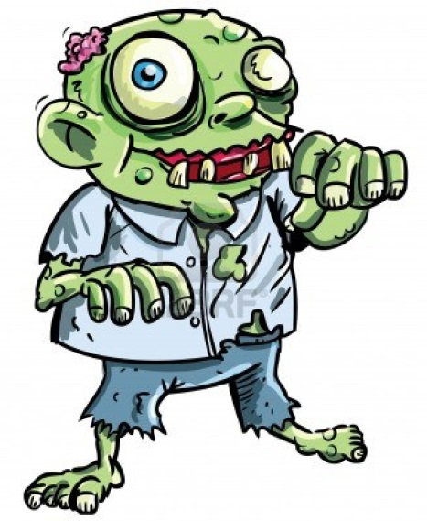

In your new compound, the following conditions exist:

- 25% of population is under 12
- 25% of population is 12- 17
- 50% of population is 18 and older
- the natural resources in the area will allow you to survive as long as everyone works 6 hours a day although you will have to leave the safety of the compound.
- each person that does not work 6 hours a day has their duties passed onto the rest of the population.
TASK

Your task is to create the "ideal" government for the compound. You must have realistic laws and methods for dealing with the many situations you will encounter.

How will you ensure the peaceful co-existence of the remaining humans?
The survival of humanity is in your capable hands!

Instructions

- Outline how decisions will be made in the compound.
- How will you compound be ruled?
- How will laws and decisions be established?
- Who will make the laws?
- How will laws and decisions be enforced?
- How will leaders be selected?
- How long will a leader remain the compound's leader?
- What powers and responsibilities will be given to the leader?
- Create FIVE laws for the island and explain them.

- Discuss and outline how you will survive in the compound.
- How will work be distributed?
- Who will work?
- Will there be anyone that doesn't work? Why?
- Is there any reason you will need to leave the safety of the compound? What safety parameters will you put in place to protect those who leave?

- Create a name, flag, and motto for your compound that suits its beliefs and structure.

- On chart paper, draw an overview of your compound, including the name, flag, and motto.

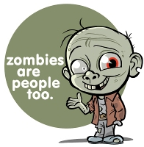
GOOD LUCK! The peaceful survival of humanity depends on your system of order and government

