Tort Law
Identify the legally acceptable defences for intentional torts, and provide an example for each.

Questions
- How can an offence be both a crime and a tort? Give an example.

- In a civil action, what does the “balance of probabilities” mean? How does it differ from the burden of proof in a criminal trial? Ch11

- Outline the elements that are necessary to prove a negligence action, and provide an example for each. Ch12

- Identify the acceptable defences for a negligence action, and provide an example for each. Ch12

Definition:

3 examples are:
Definition:

3 examples are:
Family Law

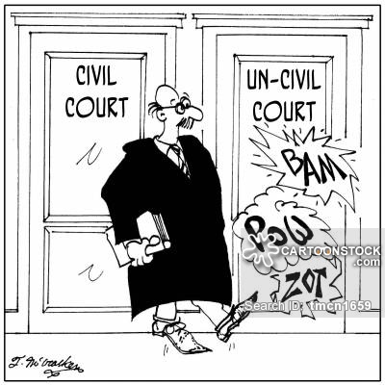

Employment Law
Definition:

3 examples are:

Contract Law
Definition:

3 examples are:

Property Law
Definition:

3 examples are:

Conduct an internet search for background details on Liebeck c. McDonald’s Restaurants, 1994 (see page 361 for more information), and discuss both sides of the case. If you had been on the jury, how would you have decided the case? What amount of damages would you have awarded Stella Liebeck, if any? Could McDonald’s avoid liability by increasing the size of its warning about the coffee’s temperature? Discuss.
ANSWER…

Do any of these claims have merit? What kind of injury did the plaintiffs suffer? How do you think they should be compensated for their loss or injury?
Murray Allen Gartton was awarded $2500 in the Federal Court of Canada. Gartton, who was serving a life sentence for murder, was injured while working in the prison woodworking shop. He claimed he was humiliated when prison officials laughed at him.

Carolyn Christian and her husband sued a guide-dog school for $160 000. A blind man was learning how to work with his dog, Freddie, when the man accidentally stepped on Mrs. Christian’s toes. She claimed she didn’t get out of the way because she wanted to see if the dog would steer the man around her.

A law student is suing his law school because they admitted him. He argued they should not have done so as he stood no chance of passing the course.

VOCABULARY!

Arbitration  Balance of probabilities  Class action  Default judgement  Garnishment  General damages  Injunction  Litigation  Mediation | Punitive damages  Special damages  Statement of claim  Statement of defence  Causation  Contributory negligence  Duty of care  Foreseeability  Libel | Mal[ractice reasonable person  Slander  Trespass  Vicarious liability  Voluntary assumption of rish

Last step!....Find a civil case to examine! You need to summarize the case, explain why it is a civil case, play judge, and jury! Decide whether you agree with the outcome of the case providing evidence to support your stance. This should be completed on a separate piece of paper.

