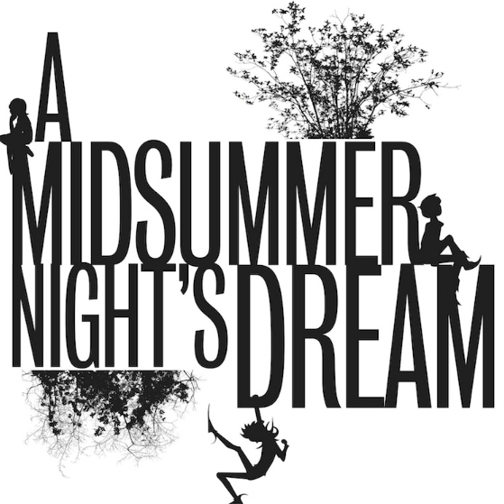

Puck
Oberon
Titania
Hermia
Egeus
Lysander
Demetrius
Helena
Theseus
Hippolyta
Nick Bottom
Quince
Flute
Starveling
Snout
Snug
Mote, Mustardseed, Cobweb, & Peaseblossom
