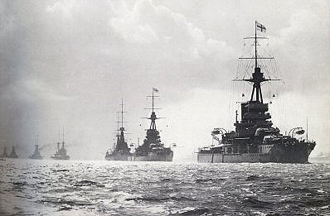Neals CHC 2D – Unit 2: WWI, Causes of World War One

**The Dreadnought**

**M**

What does this mean?

How did this contribute to the outbreak of WWI?

Specific Example:

**____________**

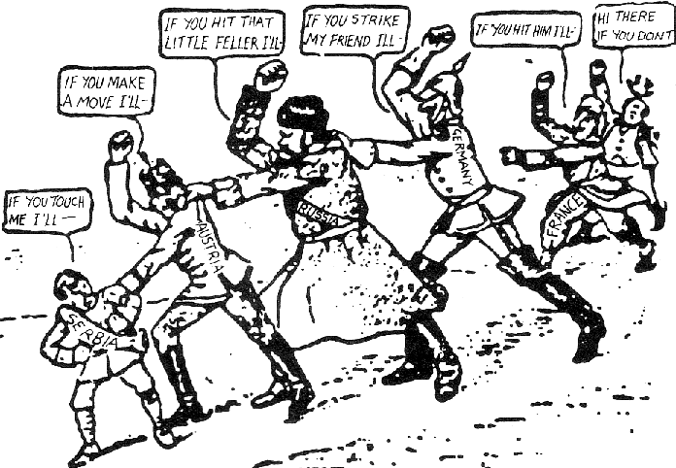**A**

**Triple Entent (The Allies)**



**Triple Alliance**



What does this mean?

How did this contribute to the outbreak of WWI?

Specific Example:

**____________**

**N**

What does this mean?

How did this contribute to the outbreak of WWI?

Specific Example:

**____________**

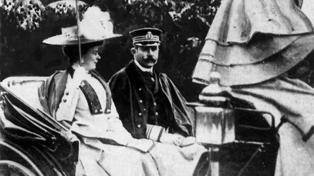**I**

**The Assassination Plan**

What does this mean?

How did this contribute to the outbreak of WWI?

Specific Example:

**____________**

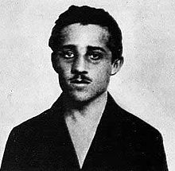**A**

What does this mean?

How did this contribute to the outbreak of WWI?

Specific Example:

**Who is the most prepared for war?**

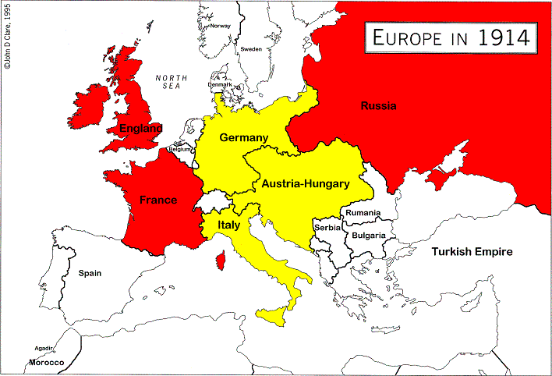



**Great Britain**

* Small in size but had lots of money and power
* Had the most powerful navy in the world
* KEY POINT – Had many colonies around the world (Canada, Australia, etc)

**Ready for war?**

**Germany**

* A strong industrial nation
* Also has a very strong army

and navy

* KEY POINT – Was power

hungry and jealous of Britain

**Ready for war?**

**Austria-Hungary**

* Many different cultures in one area
* Was a political mess: Not very organized
* A weak and outdated empire

**Ready for war?**

**France**

* At this time not as powerful as it used to be
* Is in a central location in Europe
* Also has many colonies
* KEY POINT – A mutual hate with Germany

**Ready for war?**

**Russia**

* The biggest country in the world in size
* A very large population
* Were very poor
* KEY POINT – Large army, but very scattered

**Ready for war?**