Builders Quote or Estimate – How to Decide.
What should you provide? A question to consider when providing a written price for your customers; should you provide a quote or estimate?
To decide what’s best for you – and your customer – consider the difference between a builders quote vs. estimate.
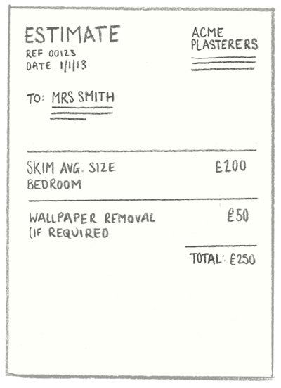 | 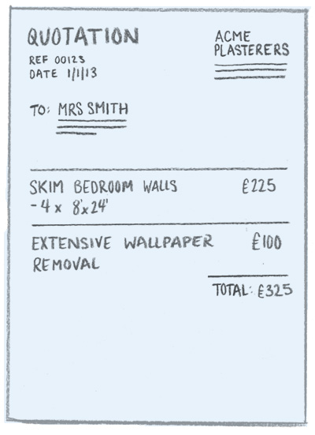
What’s an Estimate?  A best guess of price.  Informal and loose. Not used as a legal standpoint for price.  Use an estimate when: you need to give a quick ball-park price or when extra work may be uncovered once you start the job (and so the cost of the job could go up). Tip: give examples of what might increase price of job, and make sure you’re clear you’re only providing an estimate. | What’s a Quote (or Quotation)?  An Exact price for a job.  Presented formally and acts as a contract. Is a legal standpoint for price.  Use a quote when: You are pricing up a known quantity of work and are confident you can give an absolute price that won’t deviate (unless the customer asks for more work). Tip: Give your customer peace of mind. Be sure you know – and outline – the full extent of the work involved.

TIP: Consider the possible risk involved in both.

