Antigone Response Journal Suggestions

The Response Journal Collection on these four sets of questions will be on Friday, Dec. 11th.

pp. 3-17 (from the beginning to the entrance of Haemon)
- The first stage direction suggests that the set is “without historical or geographical implications” (p. 3). Why do you think Anouilh chose to tell us this?
- Does the Chorus’ information at the beginning of the play spoil the ending for you? Why do you think a dramatist might do this?
- What is the dramatic function of the Nurse?
- How would you describe the relationship between Antigone and her sister Ismene?

pp. 17-26 (from Haemon’s entrance to the Chorus’ exit)
- How would you describe the relationship between Antigone and Haemon?
- What significance can you attach to the detail that Antigone covered up Polynices’ body with dirt using “a little old child’s spade” (p. 23)?
- What are your first impressions of Creon? What kind of a leader is he?

pp. 27-49 (from Antigone’s entrance with the guards to the Chorus’ entrance)
- What does the Chorus tell us about the nature of tragedy in his speech on pp. 25-26?
- Is Creon a tyrant? Why or why not?
- Does Creon’s information about the true natures of Eteocles and Polynices change your view of Antigone’s actions? Why or why not?
- Antigone seems almost swayed by Creon’s arguments until a crucial point in the dialogue. Identify that specific point – the exact line; the exact word, if possible – and explain what Creon said that caused Antigone to continue her rebellion.

pp. 49-61 (from the Chorus’ entrance to the end of the play)
- There are three suicides at the end of the play. Whose is the most surprising to you, and why?
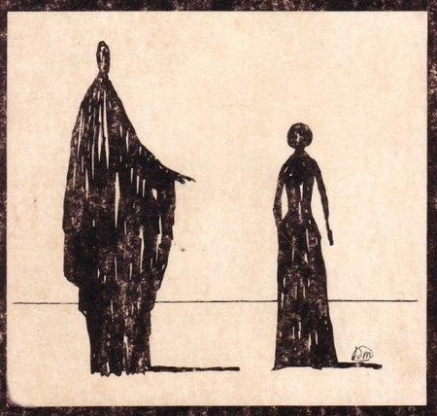
- Albert Camus, the famous French writer and existentialist philosopher, once said that “Antigone is right, but Creon is not wrong.” Discuss this idea.
- Anouilh chooses to end the play with the guards playing cards. What has their role been in the play? What do they represent? Why end with them?

