Allusions in To Kill A Mockingbird
Allusion | 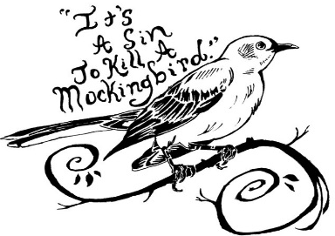  Definition/Description | How it contributes to my understanding of To Kill a Mockingbird

