“A Rose for Emily”
William Faulkner
- What do you believe to be two themes in the story? How do they relate to the plot and characters?
- What are the conflicts in "A Rose for Emily"? What types of conflict (physical, moral, intellectual, or emotional) do you see in this story?
- List three symbols in "A Rose for Emily"? How do they relate to the plot and characters?
- Do you find the characters likable? How has Faulkner created realistic characters?
- What is significant about the gray hair at the end of the short story?
- What is the central/primary purpose of the story? Is the purpose important or meaningful?
- How essential is the setting to the story? Could the story have taken place anywhere else? (example: connection between relations in the northern and southern states)
- What is the role of women in the text? What about single/independent women? What about the role of wife and mother?

- “A Rose for Emily” is narrated in first-person plural. Why do you think Faulkner chose “we” rather than “I” as the voice for the story? How might this narrative strategy be related to the description of Emily as “a tradition, a duty, and a care; a sort of hereditary obligation upon the town” (part 1 paragraph 3)?

- Describe Emily’s relationship with her father. What details in the story support your view? How does this relationship influence the development of events in the story?

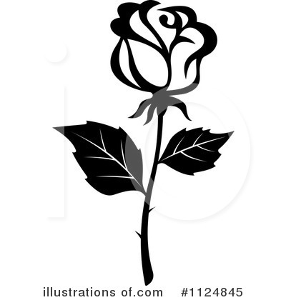
- In an interview, Faulkner described the conflict of Miss Emily: she “had broken all the laws of her tradition, her background, and she had finally broken the law of God too. . . And she knew she was doing wrong, and that’s why her own life was wrecked. Instead of murdering one lover, and then to go on and take another and when she used him up to murder him, she was expiating her crime.” How might this story be seen as expiation (atonement/ making a mends)?

- Do you believe Emily is an existentialist thinker? Explain.

